Maps of the project area (i.e., the area in which the project activities/construction will occur) and service area (i.e., the area in which all primary beneficiaries reside; also known as the income survey area) are submitted with the CDBG application. More than one map may be required to illustrate the project area, location and types of the project activities, location of the residential addresses included as primary beneficiaries (i.e., families included in the income survey), and identification of income survey respondents, non-respondents, and vacant and business/non-residential properties. Examples on the following pages illustrate the types of information to include on project area and service area (i.e., income survey area) maps.

[Note: Income survey responses may be recorded on the survey area map or a survey tracking list. For surveys involving a large number of residences, tracking responses on a survey area map may not be practical. Refer to Appendix D in this guide for income survey data tracking list examples.]

Map Example #1: Project Area/Survey Area Map with Response Type Tracking

This map type is best suited for small service area projects like street construction/reconstruction and utility improvements. Mark respondents, non-respondents, and confirmed vacant and business/non-residential properties on the survey area map. Track the data from the responses on a separate tracking document. Mark the types of work being completed in the service area on the project area map and/or the survey area map.]

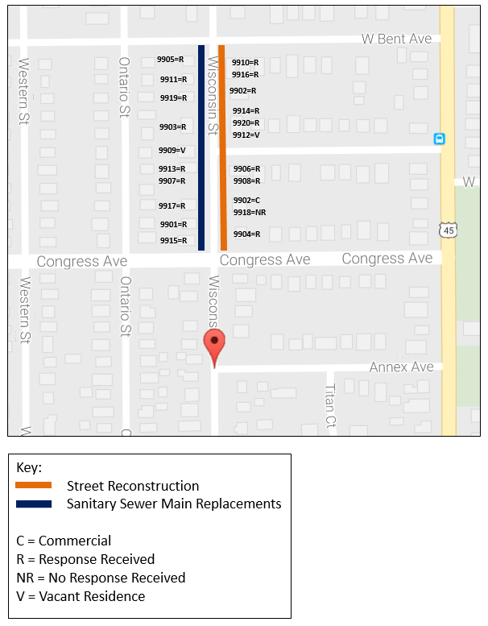
Map Example #2: Survey Area Map – Aerial View

This map type is best suited to large community-wide service areas. If this map is submitted as the Income Survey Map, an additional document is required, that includes a listing of the street addresses of all residences in the Service Area/Survey Area and response tracking.
MapQuest
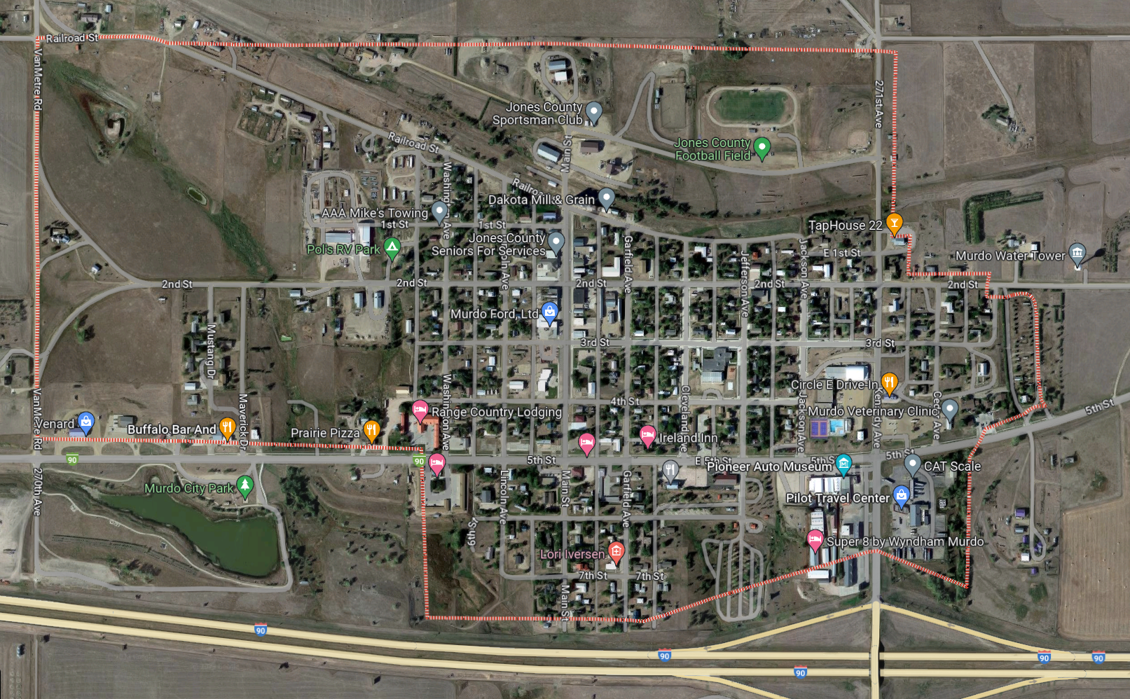

Google MyMaps
