A guidebook for conducting local income surveys for the LMI Area Objective.
Updated December 2023
LMI Area Income Survey Guidebook
South Dakota Community Development Block Grant Program
GOVERNOR’S OFFICE OF ECONOMIC DEVELOPMENT
CONTENTS
1. INTRODUCTION 2
1.1. Definitions and Terminologies 2
1.2. Service Area 3
1.3. Survey Strategy 4
2. SURVEY PROCESS 4
2.1. Critical Survey Elements 4
2.2. Define Service Area and Survey Universe 5
2.3. Create Survey Random Sample List 5
2.3.1 Calculating the Number of Responses Required 6
2.3.2 Cleaning the Survey Universe 7
2.3.3 Assigning Unique Family IDs 8
2.3.4 Drawing the Sample 9
2.3.5 Non-Responses and Unreachables 13
2.4. Publicizing the Survey 13
2.5. Determining Your Survey Approach 13
2.5.1 Mail (or Self-Administered) Questionnaires 14
2.5.2 Face-to-Face (Door-to-Door) Interviews 14
2.5.3 Web-based Survey 15
2.5.4 Telephone Interviews 16
2.6. Conducting the Survey 16
2.6.1 Survey Instrument 16
2.6.2 Making Contact 17
2.6.3 Interviewers 17
2.6.4 Contact and follow-up 18
2.6.5 The Interview 18
2.6.6 Hiring and Training Interviewers 19
2.6.7 Additional Considerations 20
2.6.8 Editing 20
2.7. Analyze the Data 20
2.7.1 Cleaning the Data 20
2.7.2 Analysis 21
2.7.3 Consistency Checks 21
2.8 Document and Save Your Results 22
APPENDIX A: General Guidance on File Security Measures 23
APPENDIX B: Sample Grant Survey Form & Instructions 26
APPENDIX C: Service Area/Project Area Map Examples 30
APPENDIX D: Low-Moderate Income Worksheet 32

1. INTRODUCTION
This Manual describes guidelines (methodologies) for conducting income surveys to ascertain whether a Community Development Block Grant (CDBG)-funded activity designed to benefit an area generally qualifies as primarily benefiting LMI persons. Section 105(c)(2)(A)(i) of the Housing and Community Development Act (HCDA) of 1974 (as amended) stipulates that an activity designed to address the needs of LMI persons of an area shall be considered to principally benefit LMI persons if “...not less than 51 percent of the residents of such area are persons of low- and moderate-income.” HUD’s regulatory requirements for conducting a survey to determine the percentage of LMI persons in the service area of a CDBG-funded activity are located at 24 CFR 570.483(b)(1)(i) for the State CDBG program.
HUD provides the LMI Summary Data (LMISD) for Grantees to use in determining compliance with the CDBG National Objective of providing benefits to LMI persons on an area basis. The LMISD must be used “to the fullest extent feasible” unless a grantee believes that the data is not current or does not provide enough information regarding income levels in the entire service area. For example, the available geographies may not conform to the activity’s service area, or the community may think that the data are inaccurate. In those cases, the community may consider conducting a local income survey, as described in this guide.
HUD LMISD

State CDBG regulations at 24 CFR 570.483(b)(1)(i) require that the survey be methodologically sound. The procedures described in this Manual are basic survey methodologies that meet the requirements of federal regulations. It is recommended that CDBG Grantees use these methodologies to ascertain that at least 51 percent of the residents of the service area of a CDBG-funded activity are LMI persons. If a Grantee chooses another survey method, the Grantee is required to demonstrate that the method meets standards of statistical reliability and receive prior approval from the South Dakota Governor’s Office for Economic Development (GOED).

1.1. Definitions and Terminologies
There are several terms and concepts used throughout the guide that may be familiar if you are or have been a CDBG recipient/grantee. We cover them here to make sure everyone is on the same page.
The definition of family includes a single person or a group of people living together, which can include children. Family members may be of any sexual orientation, gender identity, disability status, age, or marital status. A person is any individual. A household is all persons, related or unrelated, occupying a housing unit. For an income survey, we must count both families, persons, and LMI persons.

Family - 24 CFR 5.403
Household - 24 CFR 570.3

Grantees may use one of the following definitions of annual income: (1) the definition under the Section 8 Housing Assistance Payments program; or (2) adjusted gross income as defined for purposes of reporting under the Internal Revenue Service From 1040.

Section 8 Income - 24 CFR 5.609
IRS Adjusted Gross Income
Low-income person refers to a member of a family that has a combined income equal to or less than the Section 8 very low-income limit established by HUD. Moderate-income person refers to a member of a family that has a combined income equal to or less than the Section 8 low-income limit and greater than the Section 8 very low-income limit, established by HUD. Unrelated individuals shall be considered as one-person families for this purpose. Grantees are required to use the most recent HUD published Income Limits when conducting an Income Survey.

Low Income Person/Moderate Income Person - 24 CFR 570.3
HUD Income Limits

The final concept is the “service area.” The principal responsibility for determining the area served by the activity rests with the Grantee. GOED will review the service area and activity at the application to determine reasonableness. LMISD must be used to the fullest extent feasible to determine a service area’s qualification for low- and moderate-income area activities. If the available LMISD geographies do not reasonably correspond to the service area, or if the applicant considers the LMISD data for the area to be incorrect, the applicant may carry out an income survey to provide updated information to use in the application process. LMISD and income survey data cannot be used in conjunction to qualify for low-and moderate-income area activities.
HUD LMISD

1.2. Service Area
This is the area to be served by the CDBG-funded activity. One of the crucial aspects of qualifying an activity as principally benefiting LMI persons on an area basis is the proper identification of the service area. The service area must be defined first before deciding which data to use to determine the percentage of LMI persons and not vice versa. The principal responsibility for determining the area served by the activity rests with each CDBG grantee.
GOED will generally accept the determination of the service area by the Grantees unless the nature of the activity or its location raises serious doubt about the area claimed by the Grantee. The area to be served by a CDBG-funded activity need not be coterminous with census tracts or other officially recognized boundaries; the service area must be the entire area served by the activity (see 24 CFR 570.483(b)(1)(i)). The service area boundaries of GOED CDBG-funded activities may or may not coincide with census or other geographic boundaries, especially in smaller communities and rural areas where block groups or census tracts with low population densities cover large areas. One census tract may cover an entire city or there may be only two or three census tracts in an entire county. Scenarios that state grant recipients commonly face include the following:
- The service area comprises only a small portion of the unit of general local government, or of a census tract. In such situations, information on the unit of government or the census tract is not useful because the residents of the service area make up only a small fraction of the total, and their characteristics may not mirror those of the larger area. A survey of the residents of the service area may be the most appropriate way to determine whether the service area qualifies under the LMI criterion. Examples of activities in which this may be encountered include extending water lines to serve rural areas within a county; construction of a storm drainage project that only benefits a portion of a city or town.
- The service area includes all or part of several units of general local government and may contain both incorporated and unincorporated areas. It may be necessary to survey a large area to determine the percentage of service area residents who are LMI. Examples of activities include:
  - construction of a rural water system that serves more than one incorporated city plus portions of the surrounding unincorporated area of two counties in which the cities are located;
  - construction of a new fire station in a city where the municipal fire department provides, through contract, fire protection service for two adjoining townships (one of which is in a different county).
Factors to be considered in defining the service area include:
- Nature of the activity: In determining the boundaries of the area served by a facility, one must consider whether the facility is adequately equipped to meet the needs of the residents. For example, a park that is expected to serve an entire neighborhood cannot be too small or have so little equipment (number of swings, slides, etc.) that it would only be able to serve a handful of persons at a time. Conversely, a park that contains three ball fields or a ball field with grandstands that can accommodate hundreds of spectators cannot reasonably be said to be designed to serve a single neighborhood.
- Accessibility issues: If a geographic barrier such as a river or an interstate highway separates persons residing in an area in a way that precludes them from taking advantage of a facility that is otherwise nearby, that area should not be included in the service area. For example, a project for a neighborhood park would not include residents living on the other side of a freeway/highway or river that did not have an accessible pedestrian bridge.
- Seasonal residents: Seasonal (or part-time) residents (for example, residents of seasonal cabins) may not participate in an income survey if their benefit from a service or an activity is incidental. For example, the use of a library or senior center by temporary residents would be considered an incidental benefit. Seasonal (or part-time) residents should participate in income surveys for CDBG-funded activities such as the installation of sewer lines and sewage treatment plants, etc.
The American Community Survey (ACS) defines residency in terms of “current residence” – a unit is defined as the current residence of a household if the household is living in the unit for at least two months upon receipt of the survey, even if the household lives somewhere else for most of the year. In contrast, the long form uses a “usual residence” rule, i.e., the place where a person lives and sleeps most of the time. The differences in the definition of residence have consequences for vacancy and homeownership estimates. GOED does not dictate the definition of “residence” however, Grantees will be required to explain the definition used in their survey methodology.

1.3. Survey Strategy
When planning a survey, one of the first steps is deciding which data collection mode to use. Mail, telephone, web-based, and door-to-door are all acceptable modes of data collection. The choice of which mode to use should be based on the available time and resources, as well as the specific characteristics of your community. For example, if you decide that in-person interviewing is not feasible but you have a current address, phone, or email information, you may rely on a mail or telephone survey. For other communities, including an in-person survey may be critical to ensuring responses from households that lack internet access or a valid mailing address.
Research Survey Terms
- Respondent refers to the person who is responding to the questionnaire or interview.
- Rate of response is expressed as a percent; it refers to the number of families participating in a survey divided by the number of families in the sample.
- Population/Survey Universe refers to the group whose characteristics you seek to estimate.
- Sample refers to a portion of the population under survey. Samples are used to draw inferences about the population.
- Sampling is the process of selecting a sample from the population.
- Random sampling is a type of sample-selection process where one unit (say, family) of a population has the same chance of being selected into a sample as any other unit of the population.
- Representativeness refers to the quality of a sample having the same distribution of characteristics as the population from which it is selected.

This guide outlines a data collection approach that uses multiple strategies to contact people and allows them to respond in more than one way. This approach can maximize responses to surveys and help minimize costs. Such an approach begins with a “primary” mode and follows up with another mode that is intended to reach people who have not yet responded. An example is a mail invitation to complete an online survey, which includes a toll-free number allowing respondents to call and take the survey over the phone. This letter might be followed by a reminder postcard, which also includes the toll-free number. Finally, a survey team would go door-to-door and interview people in person, using a handheld tablet (or a pen and paper survey) to collect responses.

2. SURVEY PROCESS
Conducting a survey requires planning. You will need to determine the geographic range of the survey area, obtain a list of addresses, decide on a survey strategy, publicize the survey, determine a data collection timeline, prepare outreach materials, and train individuals to execute interviewing (if applicable).
These steps are discussed in detail throughout this guide. Regardless of the type of survey method, consideration must be given to the needs of residents with limited English proficiency as well as residents with visual/hearing/speech impairments.

2.1. Critical Survey Elements
Confidentiality: Confidentiality is critical for both the respondents and the organization that gathers data. Data on individuals must not be shared with any staff members inside the organization other than those performing data analysis. Even then, it is best if the team works with de-identified data. Do not keep names or addresses in the final dataset. Keep a separate file that crosslinks the names and addresses with a unique ID, which can be checked in case of a data discrepancy. Keep electronic files in a secure location. Paper surveys should be kept in a locked file cabinet or drawer. Keep electronic files on a secure hard drive and password-protect them. If files are stored in the “cloud,” save them in a secure folder and protect them with a password. Passwords should be kept securely, and only necessary staff should have access. More information on handling Personally Identifiable Information (PII) can be found in Appendix A.
Correct income limits: HUD publishes CDBG Income Limits annually. Grantees must use the most recently available Income Limits which can be found on the HUD website or through GOED.
Distinct family units: Count one family per survey. A family is a group of people who are related by blood, marriage, or adoption. A household can contain multiple families and encompasses all the people living in a dwelling unit. Unrelated individuals are considered one-person families for the income survey. (24 CFR 5.403, 24 CFR 570.3). Your survey methodology must account for the possibility of more than one family per dwelling unit.

2.2. Define Service Area and Survey Universe
The first step in preparing to conduct a local income survey is to define the geographic range of the survey area. One of the crucial aspects of qualifying an activity as principally benefiting LMI persons on an area basis is the proper identification of the service area. It could be a city, county, water district, or a smaller area inside a town. The population will consist of all families that will benefit from the CDBG-funded activity. The service area must be primarily residential. You can use the LMI Mapping Tool available from HUD to help define the area. The Mapping tool will also allow you to assess the reported income levels for the area. After defining the service area, the next step is to find a list of all addresses for that area from which to draw a sample. This list is the “Survey Universe.” A Survey Universe can be created utilizing an address list from the utility or local government tax rolls. Any list that includes all (or most) of the residential addresses in your service area can be used as the starting point for your Survey Universe. Once the entire list of addresses has been created, the Grantee will need to review the list for accuracy.
HUD Demonstrating Area Benefit Webinar

At this point, the Grantee will remove any non-residential addresses including commercial or retail locations, government offices, churches, courthouses, shops, factories, and vacant lots. The Grantee must also verify that any multi-unit buildings are accounted for in the list. For example, a utility might have one address for an apartment building that includes 4 units. Each unit needs to be included in the Survey Universe as a residence.

2.3. Create Survey Random Sample List
Proper sampling is necessary to get results that will be representative of your community. A simple random sample is an appropriate approach to gathering reliable information about the percentage of LMI persons living in the service area. The goal is to produce an independent sample that will allow for meeting target response levels and minimizing bias for the chosen survey strategy.
The simple random sampling process begins with determining the minimum number of responses that are required for the service area. Next, you must obtain and clean a sampling frame. The sampling frame is a list of addresses for the geographic area you are planning to survey. After you have cleaned the addresses in the frame, you are ready to draw the sample. The steps for drawing the sample involve utilizing a random number generator, sorting the frame by the random numbers, and selecting the number of addresses needed, which must be more than the minimum number of addresses required; this practice is called “oversampling.” Most of your time will be spent cleaning the list, as drawing the sample is a straightforward process.

2.3.1 Calculating the Number of Responses Required
After you have defined your population and selected a method for identifying individual families in the service area, you must next determine how many families to survey—that is, the sample size. A sample is representative of the population from which it is selected if its aggregate characteristics closely approximate those same aggregate characteristics in the population. The larger the sample, the more likely it is that its aggregate characteristics truly reflect those of the population. However, sample size is not dependent on the size of the population, for large populations. This means that a random sample of 500 people is equally useful in examining the characteristics of a state of 6,000,000 as it would a city of 100,000 or 50,000. For this reason, the size of the population is irrelevant when it is large or unknown; however, it becomes relevant when dealing with sparsely populated areas. Nonetheless, keep in mind that small sample sizes (relative to the size of the population) are also prone to be unrepresentative of the population and may bias your results, and require more work in the analysis section of the survey.
HUD CPD Notice 14-13
HUD CPD Notice 19-02
HUD has provided detailed information regarding requirements for determining sample size for the CDBG program through two main CPD Notices. Two key factors are the confidence level and the margin of error.
- Confidence Level = 90% (formerly 95%)
- Margin of Error = maximum of 10% based on ACS data
Many sample size calculators are available online, including those listed below, that will assist the Grantee in determining the required sample size with the HUD required confidence level and margin of error factors.
- https://www.surveymonkey.com/mp/ sample-size-calculator/
- https://www.qualtrics.com/blog/calculating-sample-size/
- https://www.calculator.net/sample-size-calculator.html
The example below is from SurveyMonkey:
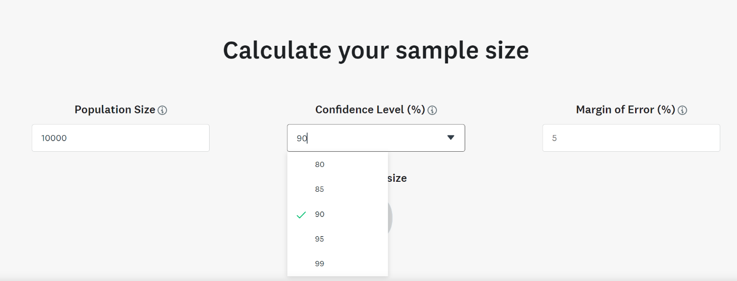
Figure 1
- In the “Population Size” box, enter the number of housing units that were determined in your Survey Universe,
- The confidence level must be set at a minimum of 90 percent, and
- The margin of error (MOE) must be no higher than 10 percent. If the MOE associated with the ACS estimate for the area is lower than 10 percent, the lower MOE must be used.
Increasing the confidence level and decreasing the MOE will create more accurate survey estimates, which will increase the sample size required.
As illustrated by Figure 2, if you have an estimated Survey Universe of 1,200, the minimum required number of responses is 66. You are not required to stop at 65 responses; you can collect as many more as you have time and funding to support. If you have the time and staffing available to gather more responses, it will improve the estimate for your area.
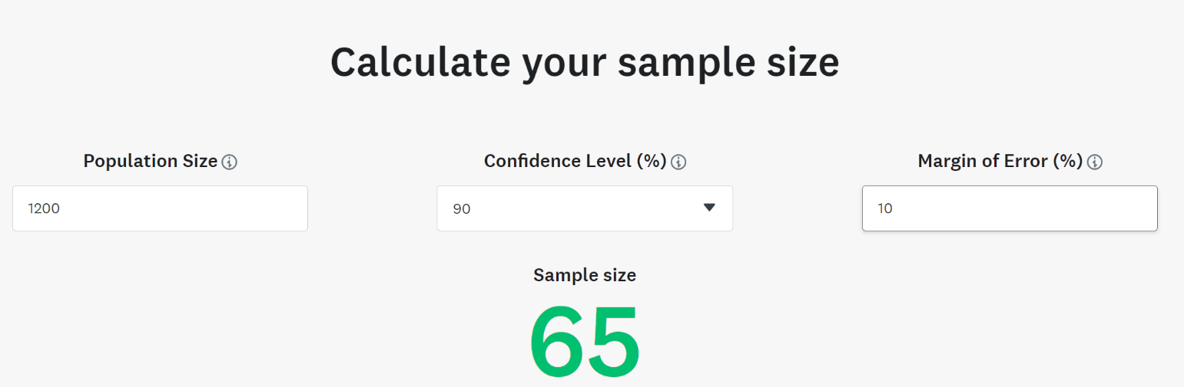
Figure 2

2.3.2 Cleaning the Survey Universe
Before drawing the sample, the Survey Universe must be cleaned. All vacant and commercial/retail addresses must be removed.
Only residential addresses should be sampled. Follow the steps below to ensure a clean list of addresses for the sample:
- Work with the lists in a spreadsheet (such as Excel), which will facilitate mailing, sorting, and comparing lists, if necessary. It can also help identify duplicate addresses.
- Review all the addresses and ensure that they are complete. If you cannot correct an incomplete address, remove it from the list and save it to a separate worksheet for documentation.
- You may need to merge or rearrange fields to create a usable mailing list, including arranging the spreadsheet with one address per row. Complete all of these edits before sampling. Later in the process of sampling or while conducting the survey, if more than one family lives at the same address, you will add one row for each family at that address. Note: Although the list may include the name of the known resident you should address any letters to “Current Resident”, to ensure that the family that is currently occupying the residence completes the survey.
- Depending on the source of the list, you may have two addresses for each name: a street address and a mailing address. Plan to send the surveys to the mailing address if it is local. If the mailing address is in a different city than the street address, it may be for the owner and not the resident. Surveys must be completed by the resident(s) occupying the housing unit.
- For locations where residents primarily receive mail at a P.O. Box, but only a street address is provided, you may either include them in the mailing or reserve them for an in-person visit. If the letter is sent to a street address where P.O. Boxes are used, it may be returned as undeliverable. These locations should be visited in person.
- Remove any vacant addresses from the list. Remove commercial addresses such as stores, churches, community centers, and similar locations. Only residential addresses should be part of the list.
- If there are multi-unit buildings, make sure each unit has a separate row in the spreadsheet. This includes retirement homes, assisted living, or other congregate housing.

2.3.3 Assigning Unique Family IDs

www.Random.Org
www.Calculator.Net
www.CalculatorSoup.com

Before drawing the sample, you should assign two or more unique family IDs for each of the addresses in the sample. This will allow for multiple surveys to be completed at a single address if there is more than one family in residence. The IDs will be used to access either a web survey or the survey administered by the in-person interviewer. It is important to assign the IDs before drawing the sample; if you assign them later, it will be difficult to ensure that the IDs are unique if you need to resample or add cases. Random.org can be used to generate IDs and random numbers. Other sites with random number generators include Calculator.net and CalculatorSoup. com.
The following steps will help you generate the unique IDs
- Go to Random.org (or another site of your choosing) and select “Lists & More” at the top of the page. Select “Strings” or “String Generator.” The string is a series of numbers and letters.
- In the box next to “Generate,” enter the number of strings you need (the maximum is 10,000).
- The number of IDs you need will depend on the total number of addresses in the clean survey universe. For example, if you have 1,200 addresses, you will need a minimum of 2,400 IDs (2×1,200).
- Choose “Uppercase letters”—this will avoid confusion for respondents and interviewers when they enter the IDs.
- Check “Each string should be unique.”
- Click “Get Strings.”
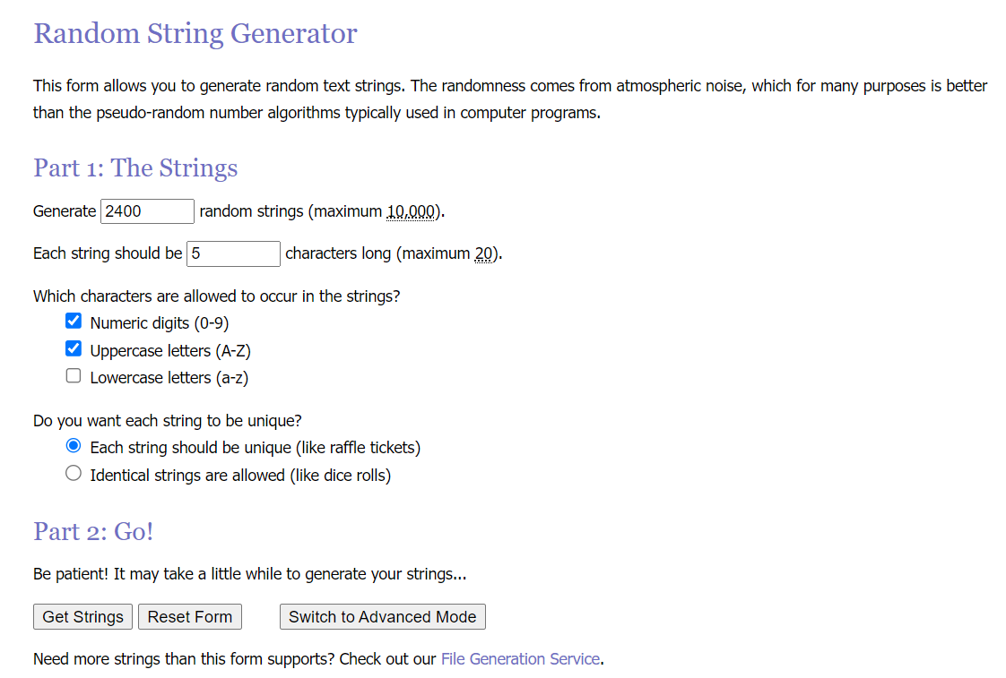
- The strings will appear on a new page as a text list. Cut and paste the list into an Excel file and then paste the IDs next to the addresses in the sampling frame.
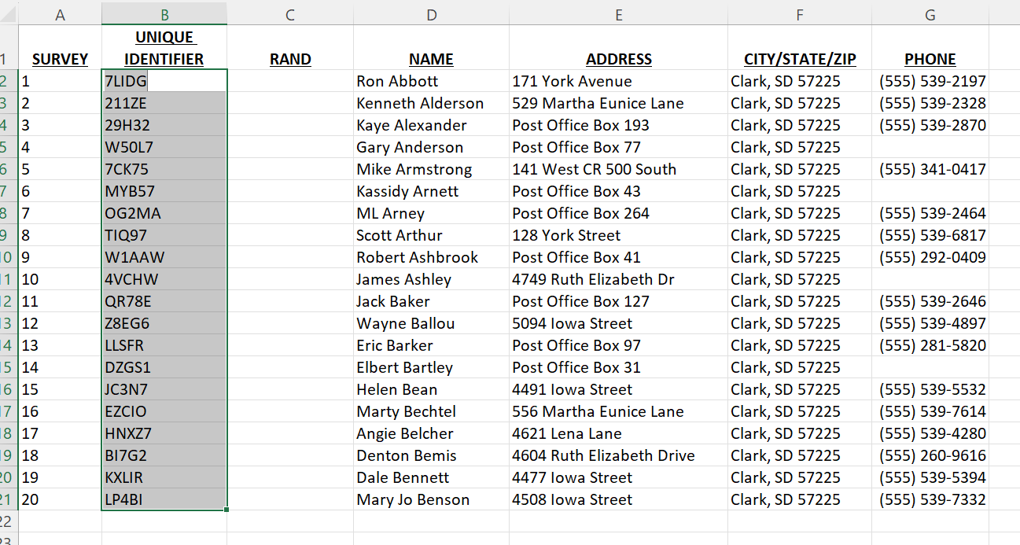

2.3.4 Drawing the Sample
In sampling, you are looking at a portion of everyone in a group and making inferences about the whole group from the portion you are observing. For those inferences to be most accurate, everyone who is in the group should have an equal chance of being included in the sample. This is called a simple random sample. Once a list of your population has been made, the next step is to randomly select the requisite size of the sample from the list.
After the list is cleaned and the unique IDs are assigned, you may generate random numbers and proceed to sampling. Drawing the sample is a crucial step in the survey process— be sure to carefully review the steps below before you begin.
The information generated in this process will be entered into the same Excel spreadsheet as the Survey Universe. Create a new field for random numbers. This will be used to sort the data for sampling.
TIP: Draw at least 150-200% of the sample required to account for non-responses. This is oversampling, which is a statistically sound approach.

You should draw at least 150–200 percent of the number of addresses required to account for non-responses. This will ensure that you receive a sufficient number of responses to the survey to meet the required sample size stipulated in the guidelines. In the example used previously, 65 is the minimum number of responses needed. Consider drawing a sample of 98-130 addresses to ensure that the minimum number of complete surveys is achieved. Drawing an oversample is a statistically sound approach, which recognizes the reality that 100 percent response rates are very unlikely. Follow the steps below to generate random numbers:
- Draw random decimal fractions from Random.org
Random Decimal Fraction Generator

- Under “Step 1: The Fractions,” put the number of fractions needed. This number is equal to the number of addresses in the cleaned sampling frame (one per row). The example is 1,200.
- Use five decimal places.
- Format in “1” column.
- Click “Get Fractions.”
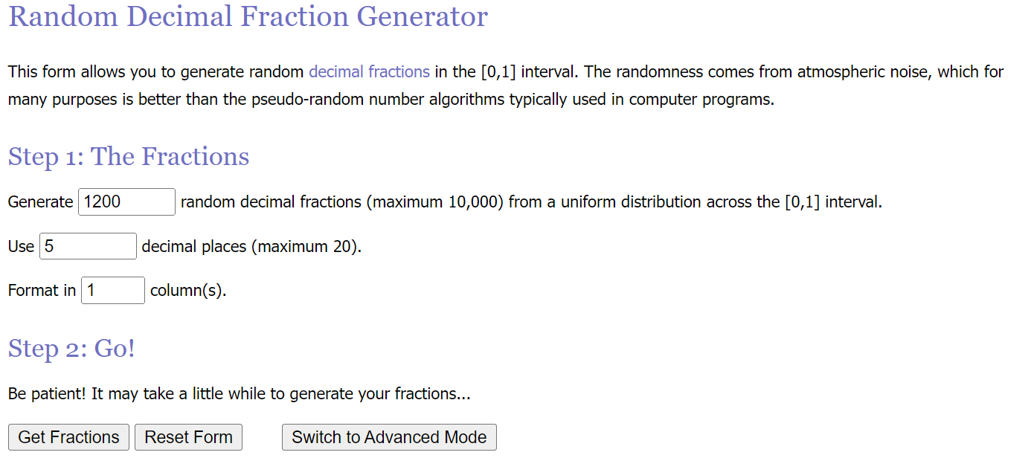

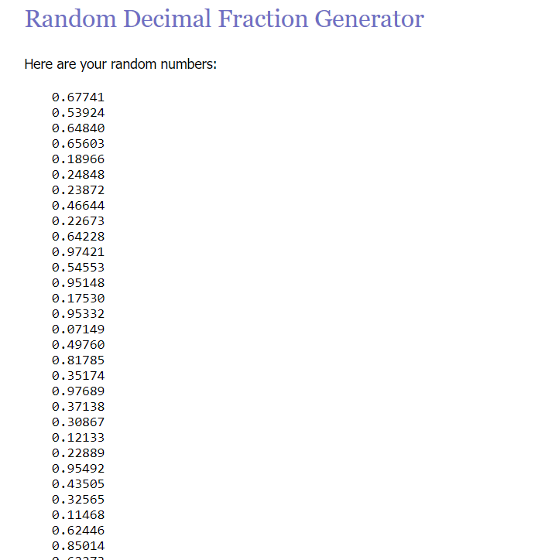

- Copy the list and paste it into the “Random Number” column in the Survey Universe Worksheet.
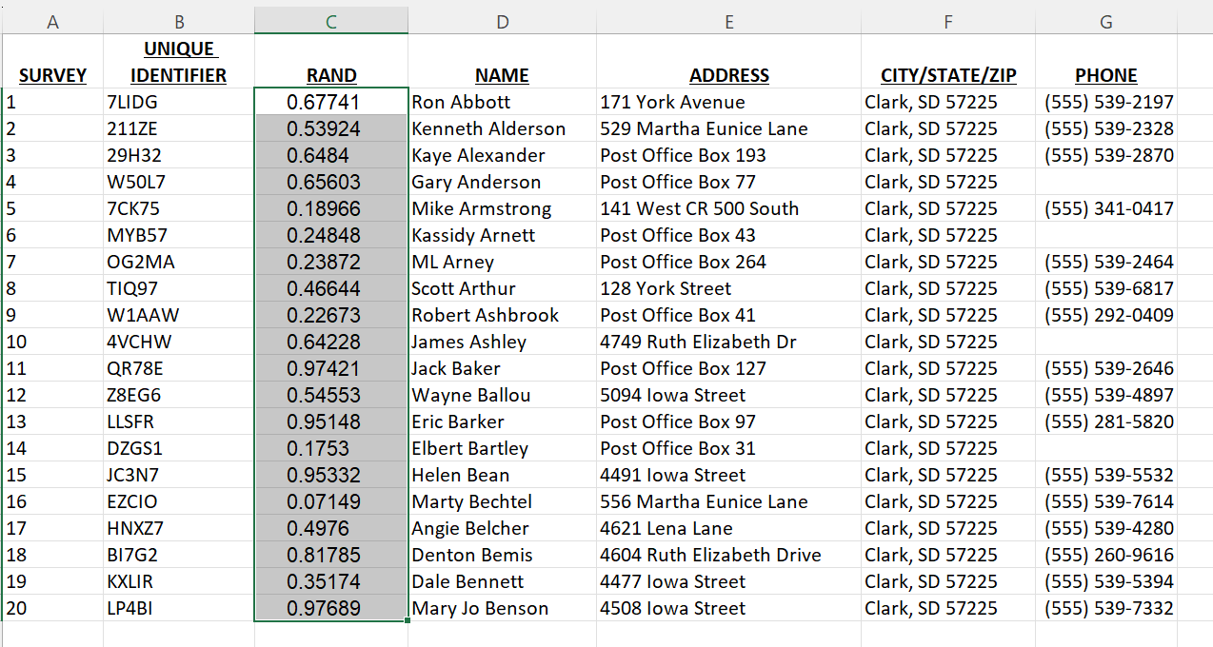

- Select all the columns with data and Sort by the Random Number column. Now the addresses are in random order.
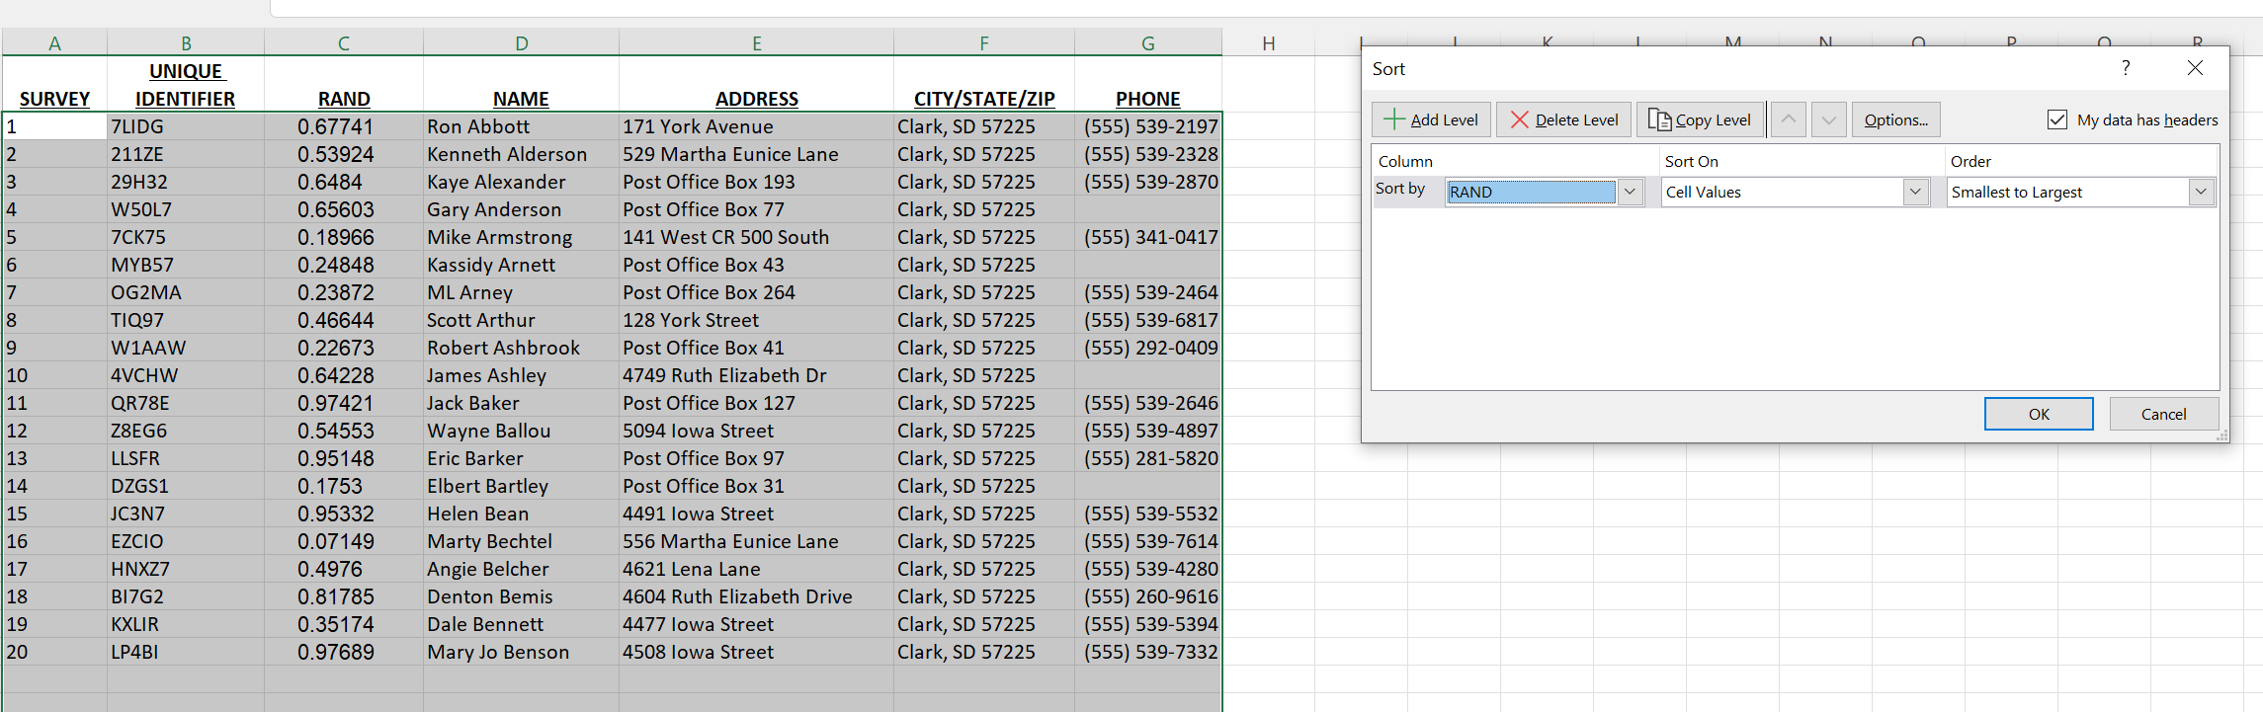
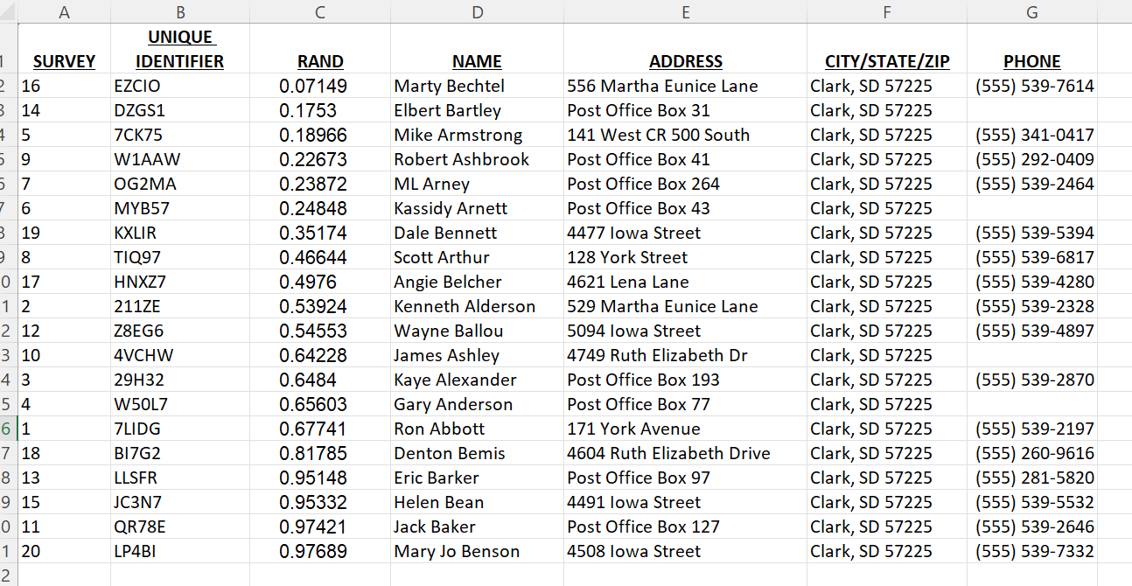
- The first 130 rows are the random sample for the example of 1,200 addresses.
- Generate random numbers in the Excel worksheet
- Make sure to save your Survey Universe Worksheet.
- Create a column next to the Unique ID column in the Excel worksheet.
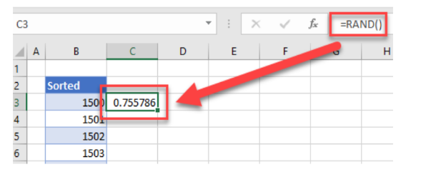
- Enter =RAND() into the first row in the worksheet.

- Copy the =RAND() formula down to the bottom of your Excel list.
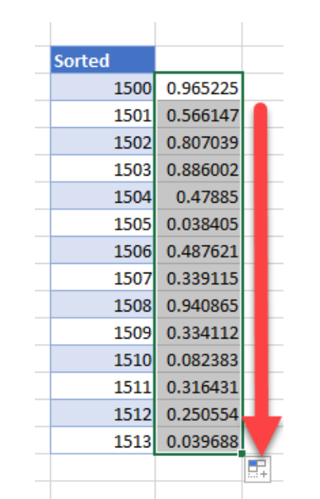
- While all the cells in the column are still highlighted, right-click to Sort.
- Sort smallest to largest or vice versa.
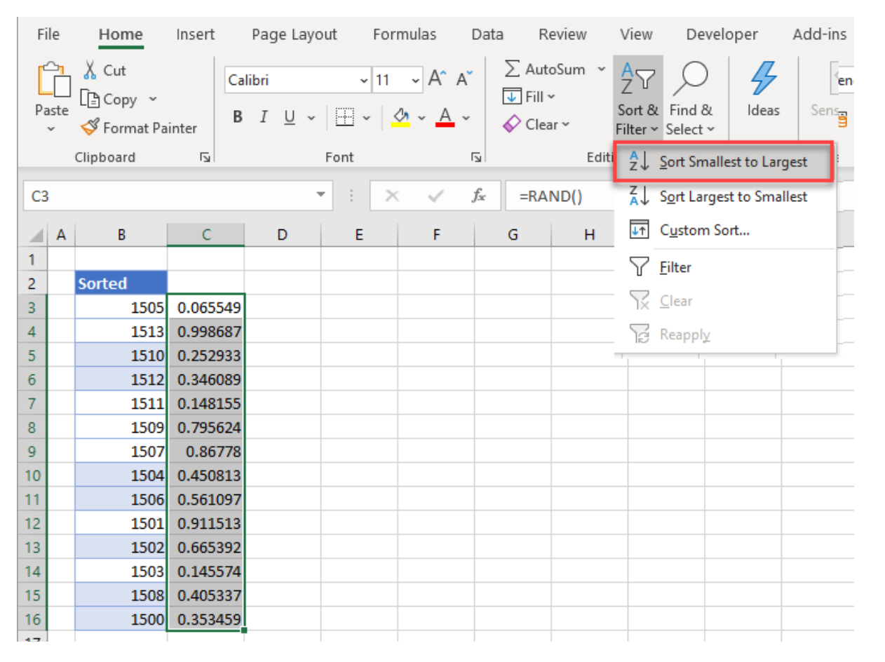
- When the warning pops up “What do you want to do?” - accept “Expand the selection” and click Sort.
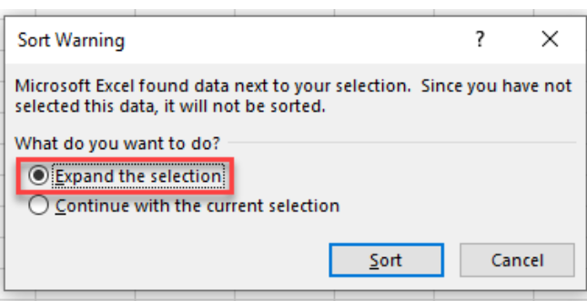
- The list of Unique IDs will be sorted randomly. Save the randomized Survey Universe with a new name.
- You can now remove the =RAND() helper column from the worksheet.

2.3.5 Non-Responses and Unreachables
You will achieve more accuracy if you are not too quick to write off a family as non-responsive. You are more likely to achieve randomness if you obtain interviews from the families in the initial sample. Thus, if you are doing a door-to-door survey, you probably should make two or more passes through the area (preferably at different times) to try to catch a family at home. If a family says that it is busy, then try to make an appointment to conduct the interview later. Only after at least two tries or an outright refusal should a sample family be replaced.
Non-responses: No matter what you do, some families will not be home during the time you are interviewing, some may refuse to be interviewed, some will terminate the interview before you finish, and some will complete the interview but fail to provide an answer to the key question on income level. The decision to get responses from replacements may become inevitable if the proportion of non-responses is high enough to affect the validity of the results of the survey. Non-response rates greater than 20 percent may affect the validity of the survey. If the non-response rate is too high, there is the risk of not having enough LMI respondents to make the required percent of the total population of the service area.
Unreachables: You must document how you account for any unreachable families in your population. A family cannot be excluded from the sample because it does not fit easily into your sampling methodology. For example, in a telephone survey, you must devise a method for contacting those families without telephones or those with unlisted numbers. These families must be included in your population listing.

2.4. Publicizing the Survey
It is very important to publicize your survey to community residents before data collection begins. Publicizing the survey in advance will help raise awareness and potentially increase response rates. Providing information about the survey will increase people’s comfort level with the purpose of data collection and motivate them to participate. It is helpful to emphasize that the survey results will only be used to apply for federal funds to improve the community and that the participation of each resident will ensure that these data are accurate. Every survey response is important. You should state that all data will be kept confidential, no personally identifiable information will be associated with the results, and none of the data collected will be used for any commercial purposes.
There are many ways to let area residents know about the survey, including public meetings, informational mailings, public notices (such as at libraries, town halls, grocery stores, or other notice boards), newspaper articles, community Listservs, social media, and city council meetings. Encourage people to spread the word about the survey. Even though not everyone will be asked to participate, the more people know about the survey, the greater the acceptance of the survey will be.
As with all aspects of the survey and questionnaire, any publicity must be worded so that it does not bias the results. For example, it is better to say that the community is applying for a CDBG grant and that, as part of the application, the community has to provide current estimates of the incomes of the residents of the service area. It is not appropriate to say that, for the community to receive the desired funding, a survey must be conducted to show that most of the residents of the service area have low and moderate incomes.

2.5. Determining Your Survey Approach
Next, you will need to determine what type of survey approach you will use. The following list summarizes the types of data collection types:
- Mail/Paper survey: Mail respondents a letter that includes a questionnaire and a prepaid return envelope.
  - Face-to-Face: Send interviewers to housing units that were selected in the random sample to conduct the survey and collect data with a handheld tablet or paper survey.
- Web-based survey: Distribute via mail or email a web survey link and Quick Response (QR) code for respondents to access the survey.
- Telephone survey: Contact respondents via telephone or provide a toll-free number for respondents to call to take the survey. Record responses via the web, tablet-based survey application, Excel spreadsheet, or on paper.
It is most likely that you will need to utilize more than one type of data collection to complete the survey. For example, a paper survey will capture completed surveys from the most willing respondents with little additional effort, but a mail outreach alone will often not yield sufficient response rates to support the required sample sizes. In-person interviewing is the most labor-intensive mode, but also the most likely to increase participation rates.

2.5.1 Mail (or Self-Administered) Questionnaires
This is a basic method for collecting data through the mail: a questionnaire is a set of questions sent by mail accompanied by a letter of explanation and a self-addressed stamped envelope for returning the questionnaire. The respondent is expected to complete the questionnaire, put it in the envelope, and return it. A common reason for not returning a questionnaire is that some people may feel that it is too burdensome. To overcome this problem, researchers often send a self-mailing questionnaire that can be folded in a certain way so that the return address appears on the outside. In this manner, the respondent does not risk losing the envelope.

Advantages of Mail Questionnaires
  - Can easily cover a large geographic area.
  - Provides an opportunity for honest answers to very personal questions.
  - No travel is required.
  - Allows respondents to complete the questionnaire at their convenience.

Disadvantages of Mail Questionnaires
  - May have possible coverage errors; for example, address lists might be inaccurate or out of date (duplicate address, incomplete or wrong addresses).
  - Not appropriate for requesting detailed written responses.
  - May have a low return rate if not adequately publicized and return postage is included.
  - May not have anyone available to assist the respondent with questions, especially if the questions are in English but the respondent’s primary language is not English. Provisions must be made to provide non-English-speaking residents with a questionnaire in their native language.
  - Easiest for people to disregard, postpone, misplace, or forget about it.
  - Longer time to collect responses.
  - Costly—must pay for return postage to get an ‘acceptable’ response rate; also postage has been paid for questionnaires that are not returned.
  - Lack of control over who fills out the questionnaire (for example, a child).

2.5.2 Face-to-Face (Door-to-Door) Interviews
This is a data collection technique in which one person (an interviewer) asks questions of another (the respondent) in a face-to-face encounter. It involves more work since the interviewer must go and knock on doors to obtain interviews. However, in small areas, this type of survey may be the easiest because one can define the service area by its geographic boundaries and develop procedures for sampling within those boundaries so that a list of families living in the area is not required. Interviewers have to be well-trained to ensure that procedures are consistently followed and that responses are not influenced by facial expressions.

Advantages of Face-to-Face Interviews
  - A very reliable method of data collection.
  - Interviews may be scheduled to suit the respondent’s daily agenda.
  - The interviewer and respondent have the option to ask for clarifications.
  - The target population may be easily located and defined.
  - People may be willing to talk longer, face-to-face, particularly with in-home interviews that have been arranged in advance.

Disadvantages of Face-to-Face Interviews
  - Responses may be less candid and less thoughtful.
  - The interviewer’s presence and characteristics may bias responses.
  - The interviewer is required to go to the respondent’s location.
  - Respondents who prefer anonymity may be influenced negatively.
  - Can be time-consuming for larger sample sizes.
  - Costs can be greater per interview than other survey methods when using paid interviewers.
  - May not be able to gain access to the house (e.g., locked gates, guard dogs, “no trespassing signs,” etc.).
  - Translators may be needed when dealing with non-English speakers.

2.5.3 Web-based Survey
A web-based survey is a data collection method whereby the questionnaire is administered online (i.e., through the Internet). The questionnaire in a web-based survey may be the same as the questionnaire in mail surveys; the only difference is that rather than sending it to the respondent by mail, the questionnaire is administered online.

Advantages of Web-based Survey
  - Respondent identity can be readily protected (unlike in paper questionnaires)
  - The privacy afforded by the computer makes it easier for respondents to provide honest answers to very personal questions
  - Respondents can complete the questionnaire at their convenience within the time limit
  - Responses can be automatically validated
  - Automatic validation of responses enables the researcher to proceed directly to data analysis
  - Surveys can be designed to accommodate those with visual, speech, or hearing impairments, and can be translated into other languages to accommodate those with Limited English Proficiency

Disadvantages of Web-based Survey
  - Not all CDBG recipients have the technology and resources readily available to implement a web-based survey.
  - Low-income families may not have the internet at home and may be unwilling to go to a public library to respond to the survey therefore, it may be difficult getting a representative sample of the target population
  - Easy for people to disregard due to telemarketing fatigue
  - It is costly to incorporate features that allow participants to respond only once
  - Not easy to do follow-ups to improve the response rate
  - Equipment malfunction such as browser freeze or server crash may cause participants not to finish the process resulting in missing data
  - Lack of control over who is completing the web survey

2.5.4 Telephone Interviews
A telephone interview is a data collection technique in which one person (an interviewer) asks questions of another (the respondent) via telephone. Telephone numbers of potential participants must be selected randomly. The interviewer must ensure that the respondent is someone competent and knowledgeable enough to answer questions about family income status. In a telephone survey, you must devise a method for contacting those families without telephones or those with unlisted numbers. As the population, it may be preferable to conduct door-to-door interviews in small service areas, especially in rural areas.

Advantages of Telephone Interviews
  - Relatively easy to conduct.
  - The appearance and demeanor of the interviewer do not influence the respondent.
  - Respondents may be more honest in giving sensitive answers due to greater anonymity for respondents.
  - The interviewer may use an alias rather than his/her real name for privacy or to conceal ethnicity if relevant to the survey.
  - Allows the interviewer to ask follow-up questions.
  - No fear for personal safety.

Disadvantages of Telephone Interviews
  - May not be able to reach households with unlisted numbers, no telephone at all, or families that use only cell phones.
  - The interviewer may have problems reaching potential respondents by telephone because of the prevalence of call screening.
  - Respondents may be hostile to interviews because of experience with previous telemarketing sales calls disguised as surveys.
  - Respondents may terminate the interview abruptly.
  - Difficulty in reaching people due to reasons such as conflicting schedules.
  - It may be easier to be less candid with someone on the phone than in person.
  - Difficult to get accurate answers from non-English speakers.

2.6. Conducting the Survey
Once you have your sample list you are ready to carry out the survey. To do this you must produce enough questionnaires, recruit and train interviewers, schedule the interviewing, and develop procedures for editing, tabulating, and analyzing the results. These issues are discussed below.

2.6.1 Survey Instrument
The survey instrument must include the following elements:
- Informed Consent: Provides respondent with information about the purpose of the survey, intended use of data, and estimated time for completion, and informs the respondent that participation is voluntary.
- Household/Family Count: The number of families in the household and the number of members in each family.
- Family Income: Total combined gross annual income of all family members. This question may be designed to solicit an “above” or “below” reply based on the corresponding income limit. This method is generally considered to be somewhat less sensitive than providing an actual dollar amount, resulting in higher response rates.
- Optional Questions: The survey may include optional questions. Questions should be limited to ensure the survey’s simplicity and the time required to complete it.
Constructing an effective questionnaire requires decisions concerning the content, wording, format, and placement of questions—all of which have important consequences on the results of what you intend to measure. For your convenience, GOED has provided you with a questionnaire. This is attached in Appendix B.
All respondents must be asked the same questions, in the same order, and their responses recorded exactly, without additions or deletions. To ensure this, the questions must be well written and the exact response of each respondent recorded as it is presented. The questions in the questionnaire are designed to be short, simple, and efficient. Care was taken to keep the language as simple as possible. The person performing the survey should be sure to avoid bias and not encourage particular answers.

2.6.2 Making Contact
While the necessary questions are brief and simple, some additional factors must be considered when designing the questionnaire. First, the questions used in the survey cannot be “loaded” or biased. For example, an interviewer may not imply that the neighborhood will benefit or receive Federal funding if respondents say that they have low incomes. The questions must be designed to determine truthfully and accurately whether respondents are LMI persons. It is permissible to state that the reason for the survey is to gather information essential to support an application for funding under the CDBG program or to undertake a CDBG-funded activity in the area.
Second, bear in mind that questions about income are rather personal. Some people may be suspicious or reluctant to answer questions about their incomes—especially if they do not see the reason for the question. A good way to handle this, in addition to good publicity of the survey, is usually to put questions about income at the end of a somewhat longer questionnaire on other community development matters. In this instance, a local agency can use this questionnaire to gather some information on what the service area sees as important needs or to gather feedback on a proposed policy or project. At the end of such a questionnaire, it is usually possible to ask questions on income more discreetly. If this option is chosen, however, the interviewer should be cautioned that a lengthy questionnaire might cause respondents to lose interest before completing the survey. The ideal length would probably be less than ten minutes

2.6.3 Interviewers
It is rarely necessary to hire professional interviewers. Volunteers from local community groups and civic organizations serve well. Also, schools or colleges doing courses on civics, public policy, or survey research may be persuaded to assist in the effort as a means of providing students with practical experience.
It is best if interviewers are chosen to make the respondents feel comfortable. For this reason, utilizing interviewers from organizations that are known and regarded in the area is beneficial.
Interviewers must have all of the materials they need to complete the interview. It may be worthwhile to assemble an interviewer kit that can be easily carried and includes all of the important materials such as:
- Map of the service area. See Appendix C for sample service area maps.
- Sufficient copies of the survey instrument.
- Official identification (preferably a picture ID).
- A cover letter from the sponsor of the survey.
- An informational flyer, with the community logo, that includes basic information about the survey's purpose is a helpful tool for interviewers to display or leave with residents.
- A phone number the respondent can call to verify the interviewer’s authenticity.
- Case management log for documenting the outcome of each visit.
- Language translation services: Depending on the demographics of your community, it may be necessary to provide interviewers with the survey instrument in Spanish or another language. The interviewer can also try to identify another household member who can speak English to take or translate the survey.

2.6.4 Contact and follow-up
Interviewers should plan to contact respondents at a time when they are most likely to get a high rate of response. Telephone interviews are usually conducted early in the evening when most people are home. Door-to-door interviews may also be conducted early in the evening (especially before dark) or on weekends. You should try again, at a different time, to reach anyone in the initial sample who is missed by the initial effort.
Of course, when making contact with a member of the family, the interviewer first has to determine that the person being interviewed is of sufficient knowledge and competence to answer the questions being asked. The interviewer should only interview resident adults.
Interviewers also should follow the set procedures for replacing “unreachables” (discussed in step 2.3.3). If they must write off an interview, they should not say, “Well, I was refused an interview here, so I’ll go over there where I think I can get an interview.” This replacement procedure is not random and thus will affect the validity of the survey results.

2.6.5 The Interview
Every interview includes some common components.
- There is an introduction to the actual interview. This should be a standard introduction in which the interviewers introduce themselves, identify the purpose of the survey, and request the participation of the respondents. Usually, it is also a good idea to note the expected duration of the interview—in this case, to let respondents know that the burden on them will be minimal.
- You should have this part of the interview process memorized so you can deliver the essential information in 20-30 seconds at most. State your name and the name of the organization you represent. Show your identification badge and the letter that introduces you. You should assume that the respondent will be interested in participating in your survey—assume that you will be doing an interview here.
- If the respondent indicates that the interview should go ahead immediately, you need an opening sentence that describes the survey. Keep it short and simple, with no big words, and no details. Use the questionnaire carefully but informally. Interviewers should read the questions exactly as they are written. If the respondent does not understand the question or gives an unresponsive answer, it usually is best for the interviewer to just repeat the question. Do not attempt to guide the respondent to give particular responses. Questions should be read in the order in which they are written. The respondents’ answers should be recorded neatly, accurately, and immediately as they are provided. At the end of the interview, and before proceeding to the next interview, the interviewer should always do a quick review of the questionnaire to be sure that responses to each question have been accurately recorded.
- If you elect to include other questions they should be placed at the end. A willing respondent may end the interview before you get to the critical question. Surveys, where participants choose not to answer the optional questions, are valid as long as the family size and income questions have been completed.

2.6.6 Hiring and Training Interviewers
How interviewers are recruited and managed is up to each community. Interviewers do not need extensive field data collection experience to conduct interviews, but they will need training on the purpose of the survey, materials, contacting protocols, and confidentiality procedures. If there are local municipal staff members available to assist, that may be sufficient. Many communities use volunteers from local non-profit organizations. Some communities may want to consider hiring experienced interviewers. If the community is near a university or community college, students may be available for the survey effort as interns or for practical experience. There are several factors to consider in the interview staffing plan:
- Size of the sample required for your survey.
- Availability of municipal staff or a contractor to serve as interviewers.
- Availability of funds to hire staff to serve as interviewers.
- Availability of candidates to hire short-term as interviewers.
- Any community-specific consideration (i.e., specific privacy concerns that would make use of municipal staff collecting their neighbors’ income data undesirable).
Once hired, all interviewers must be trained on the survey’s purpose and process. Training content for each community will vary depending on whether local or non-local interviewers are used. This may include the following:
  - Survey background and goals.
  - Schedule and data collection design.
  - Respondent outreach materials.
  - Case management log and related technical training.
  - Survey administration and troubleshooting.
  - Confidentiality requirements for protecting personally identifiable information.

The following “gaining cooperation” talking points should be reviewed with interviewers as part of their training. Include role-playing exercises in training that will give interviewers a chance to practice their doorstep speeches in their own words. Practicing will help interviewers feel comfortable and sound confident.
- Always be polite, professional, discrete, and clear about your purpose.
- Always be truthful! If you do not know an answer, offer to follow up later with additional information.
- Always use titles of respect (such as Sir, Madam, Mr., Ms., or Mrs.). Do not treat people with familiarity.
- Describe the project as an important community survey.
- Explain that the survey’s purpose is to provide data to be used in the community’s application for federal and state funding to support community development projects.
- Emphasize that this is legitimate research that is supported by the community.
- Be sensitive to the fact that you are imposing on their time. If possible, obtain family size and income, as these are the most critical information for the survey.
- Be aware that the person who answers the door may not be the person who needs to complete the survey. This gatekeeper can prevent you from getting to the appropriate survey respondent, however, so you may need to gain their cooperation first. We must leave this person with the desire to convey a pleasant experience to the respondent.
- Income may be a sensitive topic. Explain that only the average income for the area is reported. While we ask for total annual family income to apply for grants with different rules at the state and local levels, only average income is ever reported.
- Assure residents that their responses will be kept confidential and their names will not be associated with their data. Their responses will only be reported in summary form.

2.6.7 Additional Considerations
Confidentiality guidelines: No names should be included in any of the materials provided to interviewers. Interviewers mustn't enter any responses about income or family size into a case management sheet. Only the unique identifier (survey number), not the name or address of the household, should be included on the paper sheet with the survey responses. The municipality must be able to tie the survey responses to the addresses for audit purposes, but they should be maintained on separate logs.
Materials storage: Interviewers should protect all survey materials and resources to ensure that privacy is maintained. This includes tablets or smartphones that have case management applications, as well as all paper materials, particularly paper case management logs. The list of sampled addresses must remain confidential. When not in use, all materials should be stored in a secure location. Materials and tools should not be left in cars or out in the open where others could see them. Interviewers should not share this information with family, friends, or colleagues.
Safety issues: Give interviewers clear instructions on how to report any incidents they encounter while in the field. Interviewers should work in pairs but may split up based on their comfort levels. If any land is posted as private property or “No Trespassing” (or “Beware of Dog”), it is recommended that interviewers do not attempt to approach the address to complete the survey and assign the case the “Inaccessible” disposition in the case log.

2.6.8 Editing
Interviewers should turn their completed surveys over to the authorized staff member or consultant who will tabulate and analyze the data. That person should review each survey to ensure that it is complete and that each question is answered only once and unambiguously. Questions or errors that are found should be referred to the interviewer for clarification. If a question or an error cannot be resolved, a replacement should be added and the new respondent contacted. Note that editing is an ongoing process because even after you have started to tabulate or analyze the data, you may come across errors that need to be addressed.

2.7. Analyze the Data
After completing data collection, it is time to clean the data and calculate the results. The goal is to determine if the area surveyed was populated by at least 51 percent of LMI persons. While the sampling unit is the residential address, the analysis is conducted for individuals at the family level. If more than one family resides at an address, surveys may be collected for each of those families. As described in the previous sections, the survey tool is set up to allow multiple families at each address to complete a survey using a unique family ID. Each survey completed for a family will count toward the total number of responses required to achieve income estimates as described in Section 2.3.1. Most addresses will have only one family in residence, in which case only one survey will be completed for that address.

2.7.1 Cleaning the Data
Before you begin data analysis, you must review and clean the data. For paper surveys, a quality control and assurance check should be undertaken after responses are entered to assure data integrity and validity.
In cases where the respondent declined to provide family size and income but did provide other information, the entire survey should still be counted as a “refusal.” These families are not included when calculating income.

2.7.2 Analysis
Once you have reviewed and cleaned the data (as discussed in Section 2.7.1) and are confident that you have a dataset with only valid income responses, you can begin the analysis.
The calculation of the percentage of LMI persons uses the total number of persons in all families as the denominator and the total number of persons in LMI families as the numerator.
Total Number of Persons in LMI Families
÷
Total Number of Persons in ALL Families

In the example where the required sample size was 65, let’s assume that 72 families responded with valid income data. Let’s also assume that there are a total of 200 individuals, 100 of whom are in LMI families. This translates to 50 percent of the persons in the sample being LMI, which is insufficient to apply for CDBG funds. If 102 persons were in LMI families, our result would be 51 percent, which is sufficient to apply for CDBG funds. GOED has provided a worksheet as Appendix D to assist in the calculation of LMI persons and the percentage of LMI.
Since the Housing and Community Development Act requires fifty-one percent (51%) LMI persons be served by an activity utilizing the Area Benefit national objective, rounding is NOT allowed to be used in determining whether an area meets the fifty-one percent (51%) threshold for national objective compliance. For example, 50.99 percent cannot be rounded to 51 percent.

2.7.3 Consistency Checks
If your analysis indicates that 51 percent or more of the residents of the service area have low and moderate incomes, then you must perform some simple consistency checks to ensure that your estimate is reliable. These consistency checks are outlined below and will help you (and the auditors of your survey) be confident that the results are representative of the project area.
- Compare your survey results to the most recent LMISD (available on HUD’s website at https://www.hudexchange.info/manage-a-program/acs-low-mod-summary-data-local- government/) for the census geography that most closely matches the service area. If there is a large difference (e.g., LMISD = 29%, survey = 57%), there may be other known factors to explain the large difference. For example,
  - there may have been a major economic downturn in the service area since the last census, or
  - the service area may be only a small part of a large census tract, or
  - the service area may be all or part of multiple census tracts combined.
- Review the map of respondents to make sure the responses were not skewed toward a particular neighborhood.
Carefully analyze each scenario and document the basis for any discrepancy.

2.8 Document and Save Your Results
The results of the survey must be documented, since those who audit or evaluate your program may want to review the procedures and data used to determine that the service area qualifies under the CDBG program regulations. You should therefore maintain careful documentation of survey procedures.
At the very minimum, the following documentation is required:
- A description of the service area and how it was determined. (i.e., utility services, town limits, etc.)
- A map of the service area that depicts what residential units were surveyed. If the Service Area map does not include this information, documentation that the responses were compared to the map ensure that there were no geographical irregularities in the response rates.
- The population list was used to select the sample. How was the population list determined? For example, if performing a mail survey, how was the list of addresses generated so that it corresponds to the service area?

- Description of the process used to determine your sample size. Did the calculation incorporate HUD requirements of CPD Notice 19-02? Include a copy of the sample size calculator screenshot including the Margin of Error and Confidence Interval of no less than 90%.
- Description of the process that was used to draw your sample from the population list. Did you use a random number generator or random number tables? Provide a summary of how these random numbers were used to select families from the survey universe. If the sample was drawn using the rand function in Excel, copies of the worksheets before and after randomization should be kept.
- Copy of the initial univers list. Copy of the initial list of families to be surveyed. Copy of the list of families actually surveyed.
- If members of the selected sample had to be replaced, document why they were replaced and the replacement procedure adopted.
- All original completed surveys (paper, online, telephone interview forms, etc.).
- Documentation of consistency checks. Maintain a record of who was contacted, and who responded. If someone (such as an auditor) wanted to verify whether the surveys were indeed completed by families in the sample, then he/she could contact some of the respondents based on the unique identifier (survey number) to verify they had been contacted and had responded to the survey. The privacy of their original responses still is protected by this procedure.
- Appendix D – LMI Worksheet
- Survey data should be retained per record-keeping requirements of the State program at 24 CFR 570.490. Keep a backup disk of your data.

APPENDIX A: General Guidance on File Security Measures
- What Is Records Management Security
Records management requires appropriate protections for both paper and electronic information.
There are three main parts to records management security—ensuring protection from physical damage, external data breaches, and internal theft or fraud.
- Why Using Different Security Types Is Important
Organizations face a range of security threats that come from all different angles, including:
- Human Error/Loss of Records
- Fire, flood, and other natural disasters
- Data breaches caused by viruses, trojans, and other forms of malware
- Employee theft and misuse of information
Since new digital hacking threats are also constantly emerging to target different security weak spots, it’s critical to use multiple types of security strategies with records management.
- Types of Security for Paper Records
Lock Everything Down
If you need to ensure that some records remain secure, you should lock the drawers, the cabinet, and the room. Not only are locks a deterrent for improper access to records, but they can also extend the time it might take to actually break into the cabinet to take or copy files.
That’s why additional measures need to be taken to ensure that your files are secure.
Flood and Fire Protection
Off-site records storage facilities use fire-suppression and climate-control systems to protect from natural disasters, adding an extra layer of protection that is not available with in-office locks.
Limit Access to Your Critical Records
How many employees have access to all of your company records? Limiting who can access, re-file, and copy company records helps eliminate human error, which could include accidentally losing records, taking records offsite, having extra copies of critical files around the office.
Make sure that all your records are handled and disposed of properly by employees that have the approval to read the contents of every file they handle. The smaller that number is the better.
Label All Records, Files and Cabinets Appropriately
Misfiled or misplaced documents can cost your entity money. Whether you have to search for it or reproduce it, you have to factor in the cost of the time it takes to find or reproduce that file, along with the additional chance that information may be compromised.
Make sure that all your records, folders, drawers, and file cabinets are labeled clearly and properly. By maintaining a consistent labeling system, you can increase the chance that a record will find its way back to the proper place and reduce the chance of losing a record that could potentially harm a program beneficiary.

Conduct Regular Audits
Once you have a records management system in place, you need to make sure that the system is maintained.
Scheduling regular audits of your critical records will help you maintain version control and reduce the chance of a data breach since you have a better chance of discovering when something valuable is missing.
Destroy Your Records Securely—and Document When You Do
Once you have determined how you’re going to manage your records, you need to make sure to adhere to your document retention plan and take the time to properly and securely destroy your records as they pass their required retention time.
Destroying (and properly documenting) all your documents helps to reduce legal liability, reduce the number of records you store onsite, and protect your critical documents from getting into the wrong hands.
Secure Storage Facilities
In addition to natural disaster protections, off-site storage facilities also implement securities like 24/7 video monitoring, locked premises, and on-site security staff.
- Types of Security for Electronic Records
If you’ve set up a records management program, you probably have a proper backup system in place. But it’s never too late to implement a way to protect your records in case of a fire, theft, or natural disaster.
Electronic Recordkeeping Security Suggestions
1. Plan how the documents will be organized and accessed before they are scanned.
Paper documents may be secured by locking them in a file cabinet or safe. Before they are digitized, however, a security hierarchy must be carefully planned, to avoid inadvertent disclosure.
2. Electronic documents need to be preserved in an original and unchangeable format.
It is important to preserve the original files in an unalterable state in order to add legitimacy to the system. When scanned, PDF is a standard storage format. Searchable PDF is even better.
3. Plan to apply security to collections of documents rather than individually.
This makes your security management tasks easier to manage. It’s a waste of time to manually adjust permission settings on a multitude of documents.
4. Grant access rights via Access Control Lists (ACLs).
ACLs are used for limiting access to sensitive files for only those who need it. Predefined lists with authorized users can be configured while any other prying eyes are locked out.
5. Ensure mobile security.
If your employees access the document repository via mobile phones or tablets, you should disable automatic login so that the secure information is not compromised should a device be lost or stolen.

6. Focus primarily on internal security.
The majority of security issues with documents are due to internal mismanagement or manipulation. Innocent threats include inadvertent deletion of documents. This may be controlled through the use of read-only permission assignment to document storage areas.
7. Keep documents on a need-to-know basis.
One of the most easily preventable ways of ensuring document security is to only allow employees or contractors access to sensitive files when they have a need for such access, and only for as long as they need access to them. This prevents inappropriate access of those documents later and will prevent potential harm to the community or beneficiaries.
8. Ensure provisions are in place to prevent user error.
Ensure that there are provisions in place to prevent non-malicious events such as accidental deletion or modification of documents from occurring by users. Remember that your employees are your most valuable assets but they are also the most likely to make mistakes. These unintentional mistakes can cause potential harm to a beneficiary whose information has been compromised.
9. Only collect information you need.
Be sure each piece of information you gather is necessary for any of the current functions or activities of your organization or agency. If you don’t need it, don’t collect it in the first place. Also…don’t collect personal information just because you think that you will use that information at a later date. Don’t store what you don’t need.
10. “Clean” information from desktop machines, mobile devices and tablets.
Be sure all personal information has been removed from electronic devices before you assign them to a different user, or send them to be recycled.
11. Be careful who has permission to download files to local machines.
Disable electronic document exports for employees who do not have permission to store sensitive documents locally.
12. Protect your document files from natural disasters.
Are your records and documents protected from fire, flood, and natural disasters? Have a backup plan that saves files in an alternative location should a disaster occur.
13. Don’t store information any longer than you need it.
It is just as important to delete files as well as keep them. Review records retention guidelines. If you don’t have a records retention schedule, create one. Schedule the destruction of electronic records you do not need to archive once they reach the end of their useful life .
14. Secure those email accounts and archives.
Email is a vital tool for all organizations. Yet it can expose your agency to significant risks due to the unintentional disclosure of confidential information, as well as data loss or destruction due to viruses or the unintentional downloading of other malware programs. Secure your employee email accounts and archives, and control via policy the types of attachments that may be emailed.

APPENDIX B: Sample Grant Survey Form & Instructions
INSTRUCTIONS FOR COMPLETING GRANT SURVEY FORM
To ensure confidentiality, survey forms should be numbered to correspond with the Random Sample Worksheet.
- Survey Unique ID Number
Indicate in this box the number of the house as identified on the corresponding random sample spreadsheet. This information is needed to validate the survey. Note: Survey information will not be accepted unless it is tied to a corresponding random sample worksheet.
- Number of Persons in the Family
This number will include all residents temporarily away from the surveyed family (e.g. college students, persons on extended vacation, etc.) Note: If there is more than one family residing in the house/apartment, a separate form should be completed by each family.
- Family Income
Income is determined by the most recently submitted IRS 1040 Adjusted Gross Income, or by computing the total income of all family members for the last three (3) months and then multiplying that number by four (4), including persons temporarily away from the family/house. Note: Income is not limited to salaries, wages, and tips. All other forms of income as specified by the Internal Revenue Service should be included (e.g. payments received from social security, pensions, annuities, dividends, taxable interest income, tax exempt interest income, IRA distributions, etc.)
- Above or Below LMI
Simply identify the box which appropriately determines the number of individuals in the family. View the dollar amount associated with that family size.
- If the total family income is below the listed amount, check the “Below ( )” category.
- If the total family income is above the listed amount, check the “Above ( )” category.
Note: To determine the appropriate dollar amounts to be identified in each block, reference the current “Income Limits” document on the HUD website at: https://www.hudexchange.info/resource/5334/cdbg-income-limits/.
How to calculate income limits for families with more than 8 persons
Income limits for families with more than 8 persons are calculated by adding 8% of the 4-person income limit for each additional family member. This is a sample of how to calculate the income limit for a family with 9 persons:
Step 1
Multiplier (A) | 4-person income limit (B) | A*B=C
.08 | 51,450 | 4,116

Step 2
8% of the 4-person income limit (C) | 8-person income limit (D) | 9-person income limit (C+D)
4,116 | 67,950 | 72,066

- Family Ethnic and Racial Information
Check the race and ethnicity that each member of the family identifies with. More than one category may apply to each family.
- Family Makeup
Enter the number of elderly (62 years or older) in family. Enter the number of severely disabled adults in the family. Indicate by checking Yes or No if the head of the family is single regardless of gender.
- Date
Enter the date the form was completed.
- Signature of Person Conducting the Interview
If the survey forms are mailed, this line should be removed. If the survey is done via telephone or face to face, this is the signature of the interviewer.

Instructions to help communities create a survey are in red italics and should not be included on the survey form.
Survey Unique ID Number:_____________________
The survey introduction should be customized for the Grantee/Applicant individual circumstances (face-to-face, mail, etc.). A face-to-face interview may include a leave behind introduction or cover letter in lieu of the general information and instructions below.
Dear Community Resident:
The GRANTEE/APPLICANT is conducting a survey of its citizens to obtain information which will determine our ability to apply for grant funds. If we do not receive an adequate number survey responses, we will not be eligible to apply for this assistance. Your participation in this survey is voluntary.
Please complete one survey per family in the household. If there is more than one family in the household, contact CONTACT NAME, TITLE, at CONTACT PHONE NUMBER or CONTACT EMAIL to request additional copies of the survey.
Kindly, return this survey by DUE DATE by Instructions for Returning Survey [e.g., Returning Survey Using a Postage Paid Envelope Provided, and/or Other Method(s)]. Survey data will be collected and compiled by CONTRACTED FIRM NAME OR MUNICIPALITY EMPLOYEE NAME AND TITLE. Survey results will be tabulated in summary form and provided to GRANTEE/APPLICANT officials and the South Dakota Governor’s Office of Economic Development. Individual responses will be kept strictly confidential.
Family Income Range
  - Does more than one family live in this household? A survey should be completed for each family.
  - Determine the number of individuals in your family and circle that number in the appropriate box below.
  - Look at the amount of money listed under the family number. Is the total family income above or below the dollar amount listed? (See instructions for calculating income)
  - Place a check after either “Above” or “Below” to match the appropriate answer in Question 3.

Use the current Income Limits for your county, as provided on the HUD website at https://www.hudexchange.info/resource/5334/cdbg-income-limits/, insert the amount in the column, titled Lmi80_YRp1 through Lmi80_YRp8 (where YR represents the program year, such as Lmi80_23p1), in the table below.

COUNTY NAME County
Household Size | Income Above |  |  | or | Income Below |  | 80% of MHI
1 person: | income is |  | at/above | or |  | below annual income | $
2 persons: | income is |  | at/above | or |  | below annual income | $
3 persons: | income is |  | at/above | or |  | below annual income | $
4 persons: | income is |  | at/above | or |  | below annual income | $
5 persons: | income is |  | at/above | or |  | below annual income | $
6 persons: | income is |  | at/above | or |  | below annual income | $
7 persons: | income is |  | at/above | or |  | below annual income | $
8 persons: | income is |  | at/above | or |  | below annual income | $

Is this residence occupied for at least six months each year? ☐ Yes ☐ No
If not, is this your primary residence? ☐ Yes ☐ No

Race, Ethnicity, and Family Makeup
Check the race and ethnicity that each member of the family identifies with. More than one category may apply to each family. Enter the number of elderly (62 years or older) in family. Enter the number of severely disabled adults in the family. Indicate by checking Yes or No if the head of the family is single regardless of gender.
Please note this information will be used for aggregated analysis purposes only. We ask you to provide this information voluntarily. If you do not wish to provide the information, you may refuse to do so.
Race (check one): |  |  |  | Ethnicity (check one):
American Indian or Alaska Native | ☐ | American Indian or Alaskan Native and White | ☐ | Hispanic/Latino | ☐
Asian | ☐ | Asian and White | ☐ | Not Hispanic/Latino | ☐
Black or African-American | ☐ | Black/African-American and White | ☐ | Family (check all that apply):
Native Hawaiian or Other Pacific Islander | ☐ | American Indian/Alaskan Native and Black/African-American | ☐ | Single Head of Household | ☐
White | ☐ | Other Multi-Racial | ☐ | 62 or Older | ☐
 |  |  |  | Disabled Adult | ☐

Date this Form Was Completed:

Signature of Interviewer: (phone/face-to-face only)

APPENDIX C: Service Area/Project Area Map Examples
Maps of the project area (i.e., the area in which the project activities/construction will occur) and service area (i.e., the area in which all primary beneficiaries reside; also known as the income survey area) are submitted with the CDBG application. More than one map may be required to illustrate the project area, location and types of the project activities, location of the residential addresses included as primary beneficiaries (i.e., families included in the income survey), and identification of income survey respondents, non-respondents, and vacant and business/non-residential properties. Examples on the following pages illustrate the types of information to include on project area and service area (i.e., income survey area) maps.
[Note: Income survey responses may be recorded on the survey area map or a survey tracking list. For surveys involving a large number of residences, tracking responses on a survey area map may not be practical. Refer to Appendix D in this guide for income survey data tracking list examples.]

Map Example #1: Project Area/Survey Area Map with Response Type Tracking
This map type is best suited for small service area projects like street construction/reconstruction and utility improvements. Mark respondents, non-respondents, and confirmed vacant and business/non-residential properties on the survey area map. Track the data from the responses on a separate tracking document. Mark the types of work being completed in the service area on the project area map and/or the survey area map.]

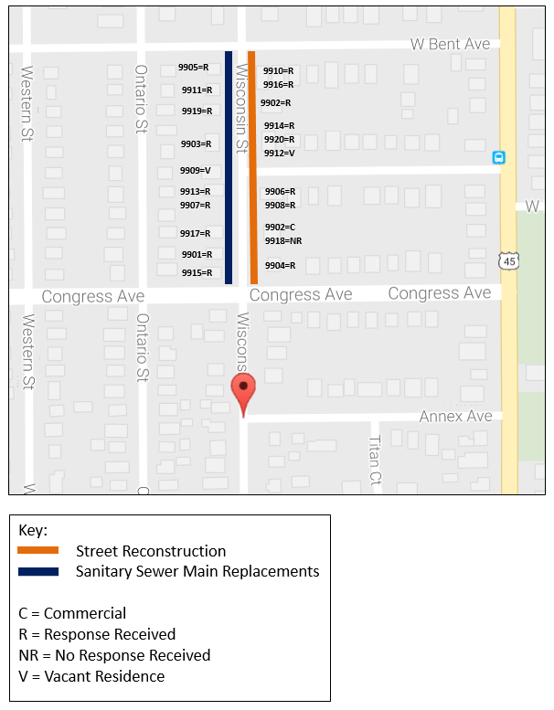
Map Example #2: Survey Area Map – Aerial View
This map type is best suited to large community-wide service areas. If this map is submitted as the Income Survey Map, an additional document is required, that includes a listing of the street addresses of all residences in the Service Area/Survey Area and response tracking.
MapQuest
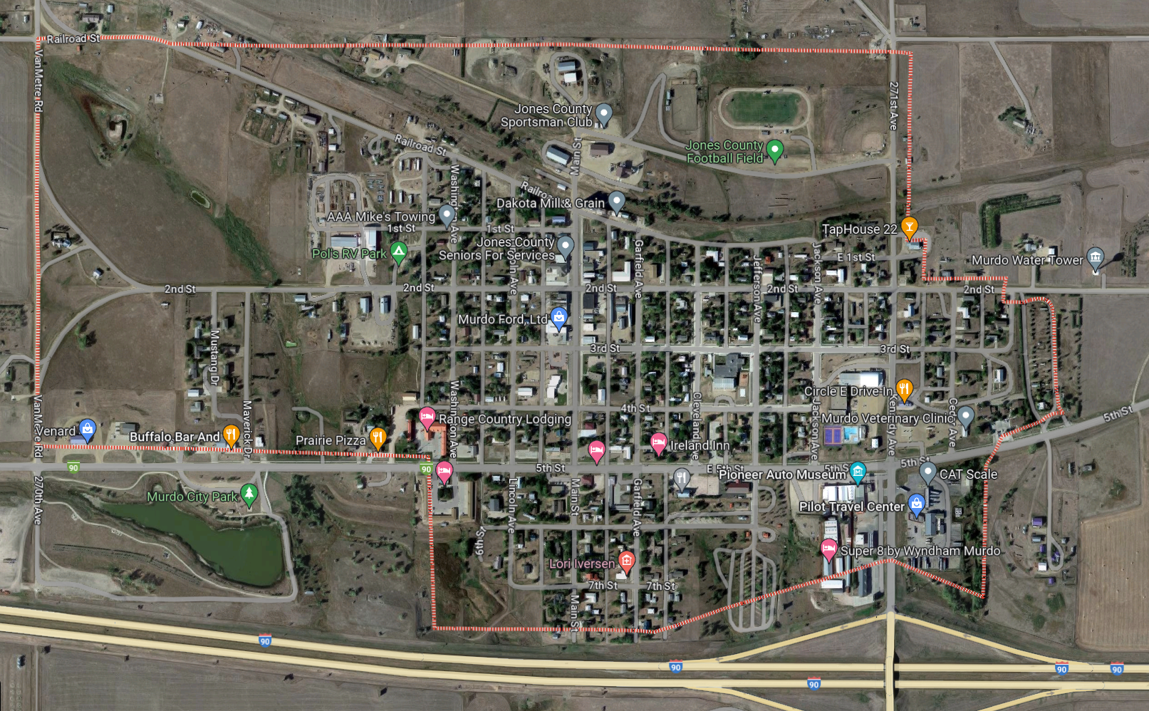

Google MyMaps
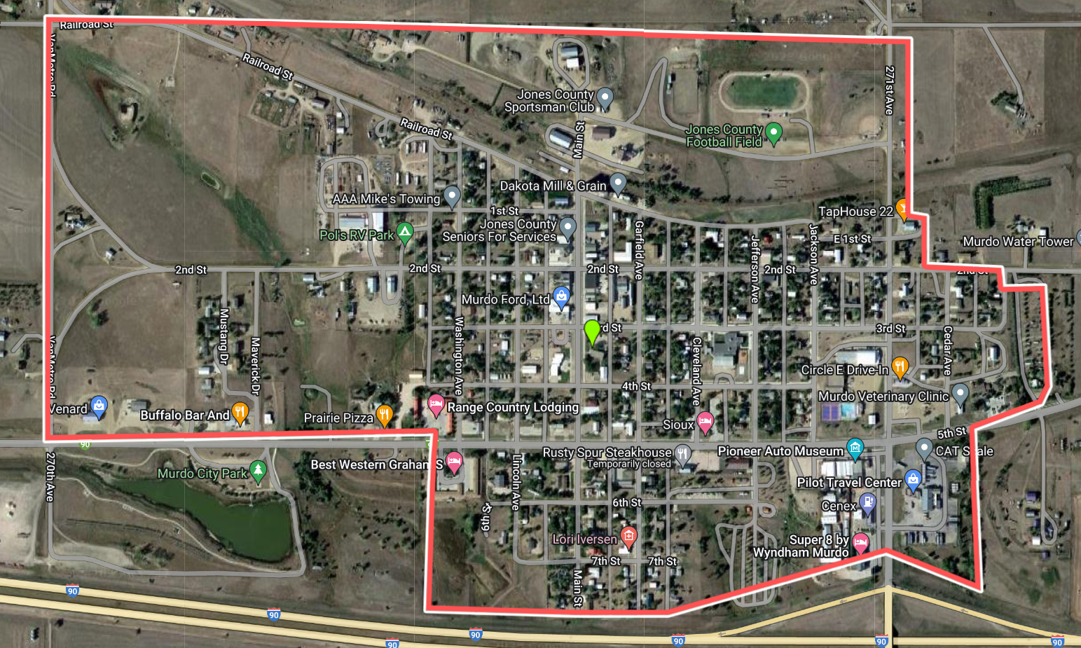

APPENDIX D: Low-Moderate Income Worksheet
PART A. INFORMATION OBTAINED FROM SURVEY
- Number of families in the target area.
- Total number of families interviewed.
- Total number of low- and moderate-income families.
- Total number of persons living in the low- and moderate-income families interviewed.
- Total number of families interviewed in which the income was above the low- and moderate-income level.
- Total number of persons living in the families in which the income was above the low- and moderate-income level.

PART B. CALCULATIONS BASED ON DATA CONTAINED IN SURVEY
- Average size of low- and moderate households (line 4 divided by line 3).
- Average size of non-low- and moderate households (line 6 divided by line 5).
- Proportion of families interviewed with low- and moderate-income
(line 3 divided by line 2).
- Proportion of families interviewed with non-low- and moderate-income
(line 5 divided by line 2).
- Estimate of total number of low- and moderate-income families in the target area (line 1 multiplied by line 9).
- Estimate of total number of non-low- and moderate-income families in the target area (line 1 multiplied by line 10).
- Estimate of total number of low- and moderate-income persons in the target area (line 7 multiplied by line 11).
- Estimate of total number of non-low- and moderate-income persons in the target area (line 8 multiplied by line 12).
- Estimate of total number of persons in the target area
(line 13 added to line 14).
- Estimated percentage of persons in target area who have low- and moderate income (line 13 divided by line 15).

