Guidance and Certification for UGLG’s completing their Four Factor Analysis and, if applicable, their LAP for their CDBG Application and project.
South Dakota Community Development Block Grant Program

Four Factor Analysis and Language Access Plan (LAP) Guidance
GOVERNOR’S OFFICE OF ECONOMIC DEVELOPMENT

FOUR-FACTOR ANALYSIS

for Limited English Proficiency Persons

COMMUNITY DEVELOPMENT BLOCK GRANT PROGRAM (CDBG)

GENERAL INFORMATION
GRANTEE NAME:
PROGAM: |  |  | FISCAL YEAR:
CONTACT PERSON: | PHONE: | EMAIL:

FACTOR #1: The number or proportion of LEP persons served or encountered
The grantee must analyze the number or proportion of LEP persons served or encountered in the eligible service area population (served or encountered includes those persons who would be served by the program or activity if the person received education and outreach and the grantee provided sufficient language services).
Select the paragraph(s) below that best describes your methodology for the analysis by placing a check mark in the box beside the description. Also, please fill in the blanks or circle the correct statement where indicated. These paragraphs may be modified or replaced with narrative that more accurately reflects the grantee’s methodology.
☐ The Grantee utilized the US Census, ACS tabulation for persons that speak English “Less than Well” to determine its municipalities’ LEP population(s). Based on this data, the Grantee (choose one) ☐ does ☐ does not have an LEP population that meets the 1,000 or 5% LEP persons threshold for any language(s) identified. Instructions on utilizing the ACS data can be found in LAP Exhibit 3 to this document.
☐ Income surveys were conducted to determine eligibility in the program or activity service area. Survey questions were asked to determine if any LEP persons are located in the project area. According to the results of the surveys, there were (number) LEP persons located in the proposed project area. The proposed project area has a total population of (number). The number of LEP persons affected by the project or activity (choose one) ☐ does ☐ does not meet the 1,000 or 5% LEP persons in the service area threshold for any languages identified.
☐ Local elected officials, clergy, medical personnel, and school administrators were polled by mail/telephone/email to request input regarding their knowledge of LEP persons within the community and/or proposed project area(s). Based on the results of the questionnaires, there are (estimated number) LEP persons out of (total persons benefitting from the program or activity) located in Name of Jurisdiction or Project Area. This (choose one) ☐ does ☐ does not meet the 1,000 or 5% LEP persons of total service area threshold for any language(s) identified.
If “does meet” is marked, the grantee must complete a Language Access Plan after completing the remaining 3 Factors.
FACTOR #2: The frequency with which LEP persons come into contact with the program
Select the paragraph below that best describes the amount of public contact of your program by placing a check mark in the box beside the description. These paragraphs may be modified or replaced with narrative that more accurately reflects the grantee’s program or activity.

☐ The proposed program or activities that provide direct assistance to the resident, which could include, but is not limited to acquisition, relocation, housing rehabilitation, water/sewer laterals, and public services. Therefore, residents are likely to have considerable direct contact with the program and its staff.
☐ The proposed project is a program or activity that does not provide direct assistance to individuals, such as road reconstruction, water/sewer line replacement, and commercial building demolition. As a result, LEP persons are not directly affected by the CDBG program or activity, and no direct assistance will be provided to the residents. However, all citizen participation activities are open to the public and every effort should be made to provide all related information to all interested residents.

If the first box is marked above, the grantee must complete a Language Access Plan after completing the remaining 2 Factors.
FACTOR #3: The nature and importance of the program, activity, or service
 The proposed project will provide critical improvements such as a new community, fire station, or other public facility that serves low- and moderate-income people with a significant number of LEP persons or a primary focus on LEP persons. The benefits of such projects have an important impact on LEP residents. The proposed project will be located in a neighborhood or area that has a high number of LEP persons who will be positively or negatively impacted by the project.
 The proposed project will not provide critical improvements such as a new community, fire station, or other public facility that serves low- and moderate-income people with a significant number of LEP persons or a primary focus on LEP persons. The benefits of such projects will not have a significant impact on LEP residents. The proposed project will not be located in a neighborhood or area.
If the first box is marked above, the grantee must complete a Language Access Plan after completing the remaining Factor.
FACTOR #4: The resources available and costs to the recipient
Include a brief summary of the resources available and the overall cost of providing language assistance. Analyze the budget to identify available funding for providing language assistance.

DETERMINATION
Once you have completed your Four Factor Analysis, use the results of the analyses to determine which language assistance measures are appropriate.
- If you determine a Language Access Plan is not required, complete the Four-Factor Analysis Completion and Findings Certification (Exhibit #1) and submit with your CDBG Application.

If you determine that a Language Access Plan is required, complete the Language Access Plan and Certification (Exhibit #2) and submit with your CDBG Application. Your LAP must include a listing of “vital documents”. Vital Documents are those considered necessary to having access to your programs, benefits, services, and activities. HUD has established certain “safe harbor” guidelines for written materials.

Size of Language Group | Recommended Provision of  Written Language Assistance
1,000 or more in the eligible population in the market area or among current beneficiaries | Translate vital documents.
More than 5% of the eligible population or beneficiaries and more than 50 in number | Translate vital documents.
More than 5% of the eligible population or beneficiaries and 50 or less in number | Translate written notice of right to receive free oral interpretation of documents.
5% or less of the eligible population or beneficiaries and less than 1,000 in number | No written translation is required.

Appendix 1

FOUR-FACTOR ANALYSIS COMPLETION AND FINDINGS CERTIFICATION
TA: If the grantee determines that a LAP is not required, then the certification below should be signed and dated by the chief elected official and submitted with their application. The entire Four Factor Analysis will be reviewed at monitoring.

Name of Jurisdiction has completed the Four Factor Analysis and has determined that there are no items identified from the analysis for this grantee, program, or activity that will trigger the need for a Language Access Plan.
Therefore, based on the Four-Factor Analysis, Name of Jurisdiction is not required to develop a Language Access Plan.
However, Name of Jurisdiction will make all reasonable attempts to accommodate the language access needs of residents requesting oral or written translation during citizen participation, income surveys, and/or direct assistance intake activities including but not inclusive of public hearings, public notices, advertisements, income surveys, and direct assistance intake documents.

Chief Elected Official (signature) Date

Printed Name of Chief Elected Official

Appendix 2

LANGUAGE ACCESS PLAN AND CERTIFICATION

As a result of the Name of Jurisdiction’s Four-Factor Analysis, the Name of Jurisdiction has identified the following types of language assistance to be provided by the Name of Jurisdiction or its subrecipient throughout the implementation of its CDBG program dependent on need:
TA: Below are the examples of activities to meet the needs of your identified Limited English Proficiency Populations. Some programs or activities do not require all items to be followed. Additional activities may be added to meet the needs of the grantees’ LEP population(s).
All CDBG citizen participation materials, public notices, and project-related resolutions will be published/posted in the LEP language(s) identified, in community newsletters, on the website, bulletin boards, at the offices and meeting location of the Name of Jurisdiction, and in public places throughout the proposed project area(s) and/or the community, especially those areas with high concentration of the affected population.
Published/Posted citizen participation notices will include a statement in the identified LEP language(s) indicating that other “program materials are available in named LEP language(s) upon request”. This statement must be in as many languages as has been identified during the Four Factor Analysis.
All direct assistance program application documents and outreach materials will be provided in the identified LEP language(s).
All public notices of income surveys and the income survey itself will be provided in named LEP language(s) identified (if applicable).
For income surveys in service areas meeting the threshold of LEP and/or direct assistance intakes, when applicable, a translator will be retained to provide oral translation at the income survey or intake site to assist in filling out the survey/intake documents and explaining the program. The Name of Jurisdiction, nor its subrecipients will require the LEP applicant to provide their own translator, however, the applicant may bring someone if they choose.
If other populations of LEP persons are identified in the future, the Name of Jurisdiction will provide additional measures to serve the language access needs of those persons.

Chief Elected Official (signature) Date

Name of Chief Elected Official

Appendix 3

Conducting a Four-Factor Analysis
for Limited English Proficiency
FACTOR #1
To conduct the Factor #1 review, you must access Census data:
- Go to https://data.census.gov/ type the name of your jurisdiction and “language spoken at home”.
- Click the search button. See below for example:
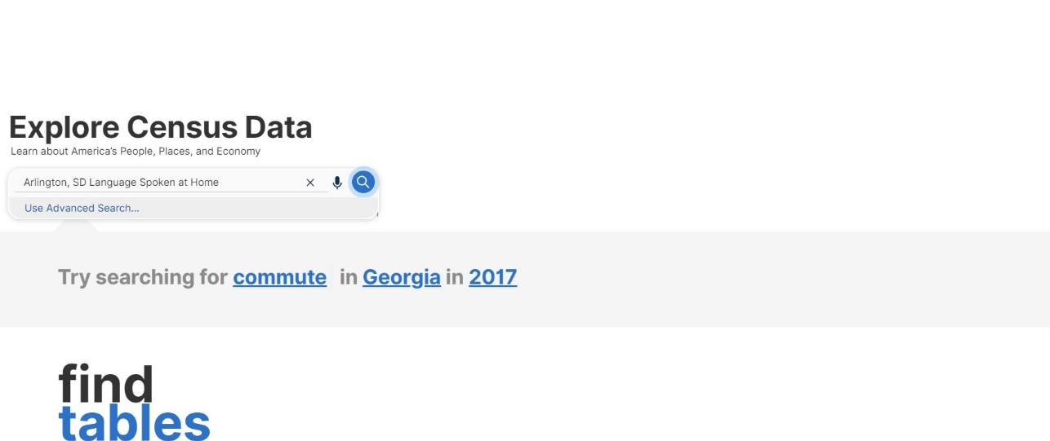

- This should take you to a page that looks like this. Click on S1601 LANGUAGE SPOKE AT HOME
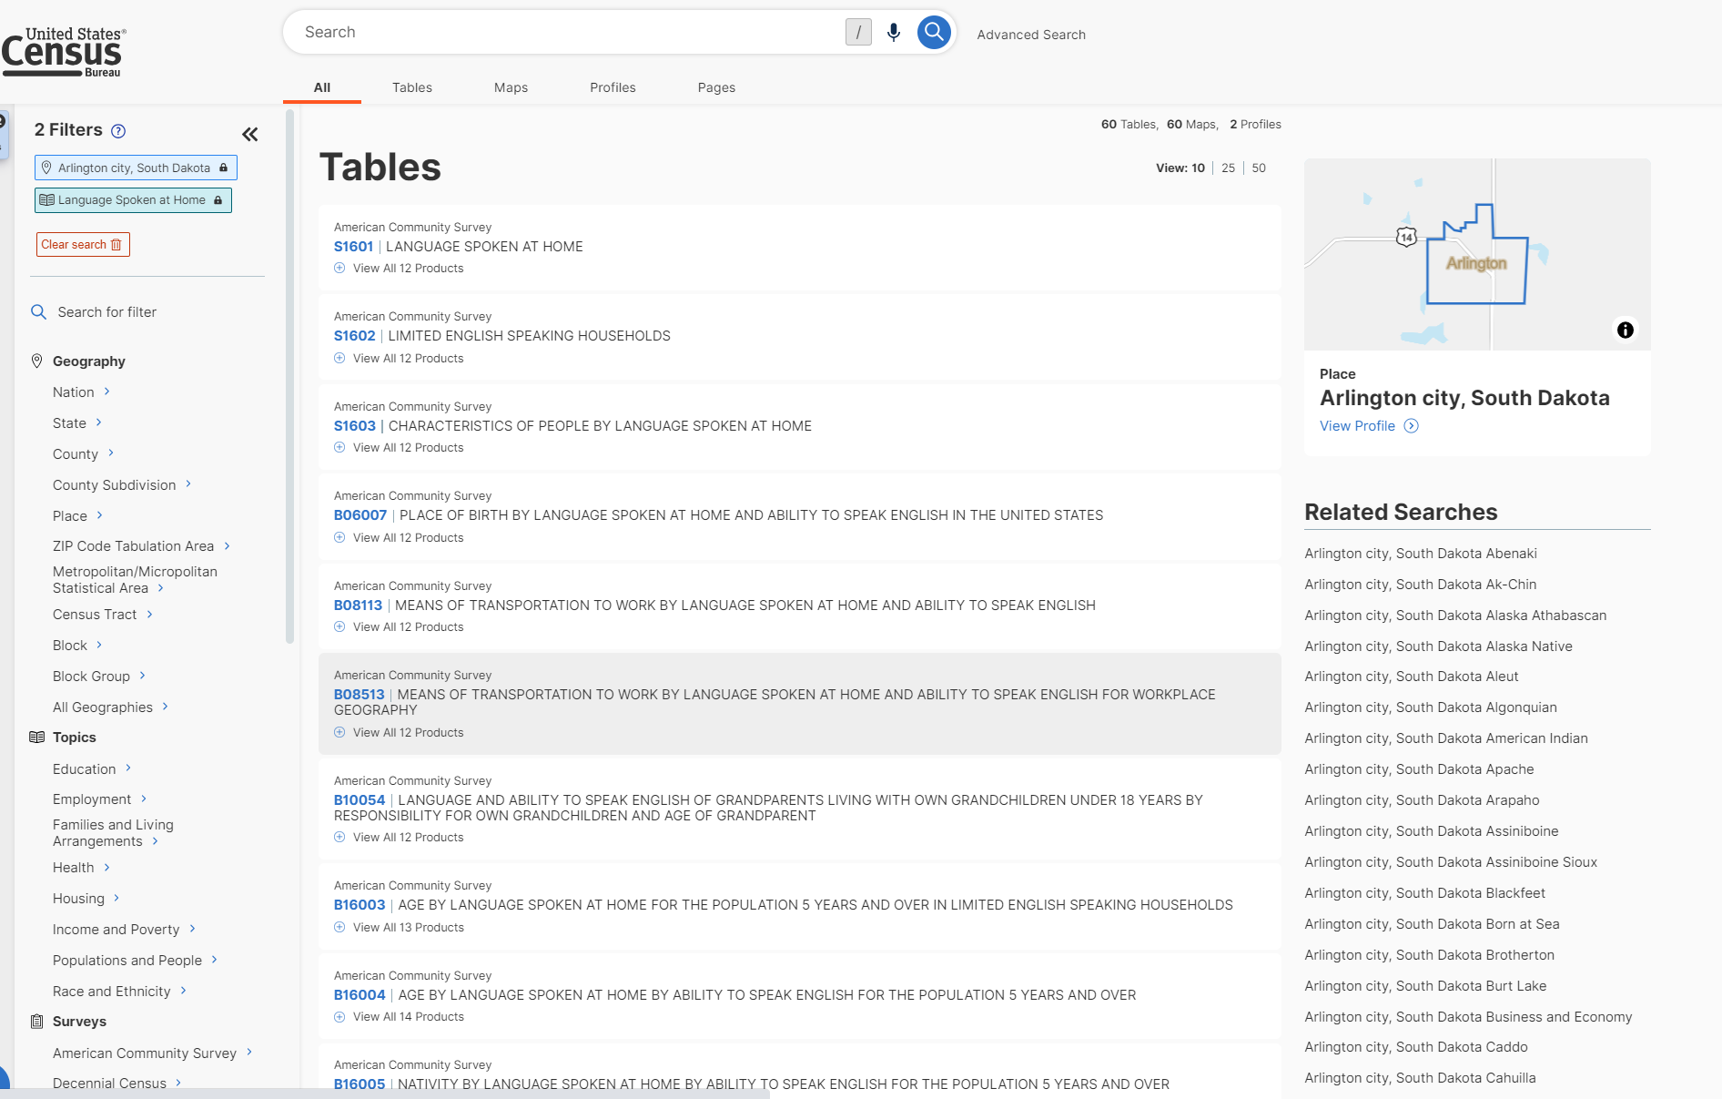

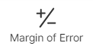
- This should bring up the table shown below. You can click the button and the button to enhance screen view.
- Scroll to the right to see the “Speak English less than very well” column.
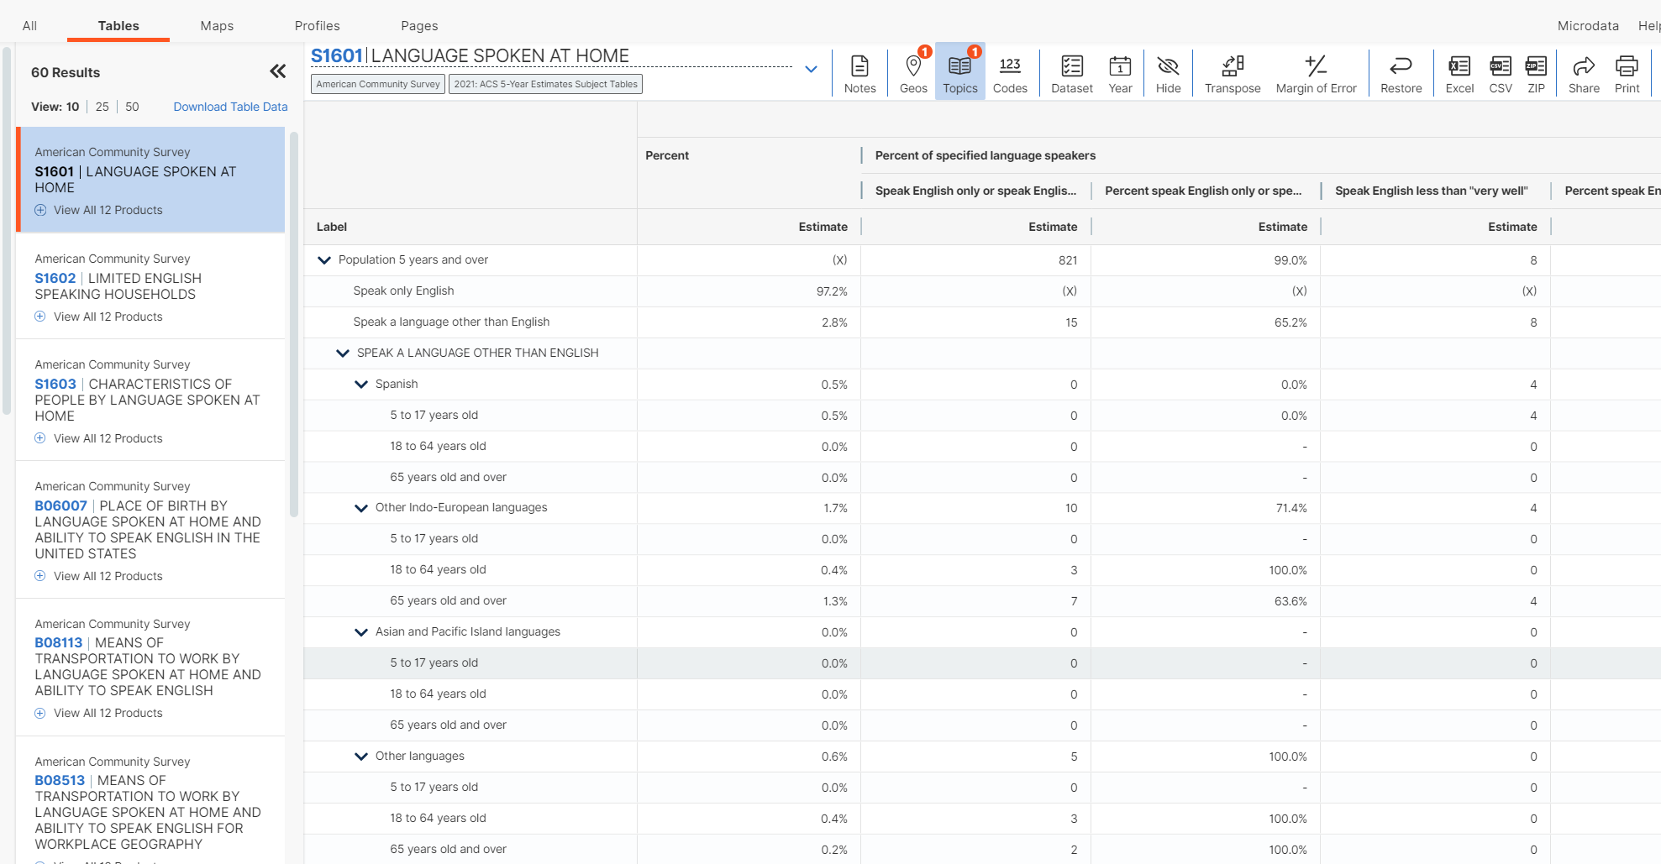

- Using the Row for each listed language group that “Speak English less than very well” (considered LEP) you will determine the number of people who “Speak English less than very well” by language. For any specific language that is 5% or more of your jurisdiction’s total population or has 1,000 or more people, a Language Assistance Plan (LAP) will be required.
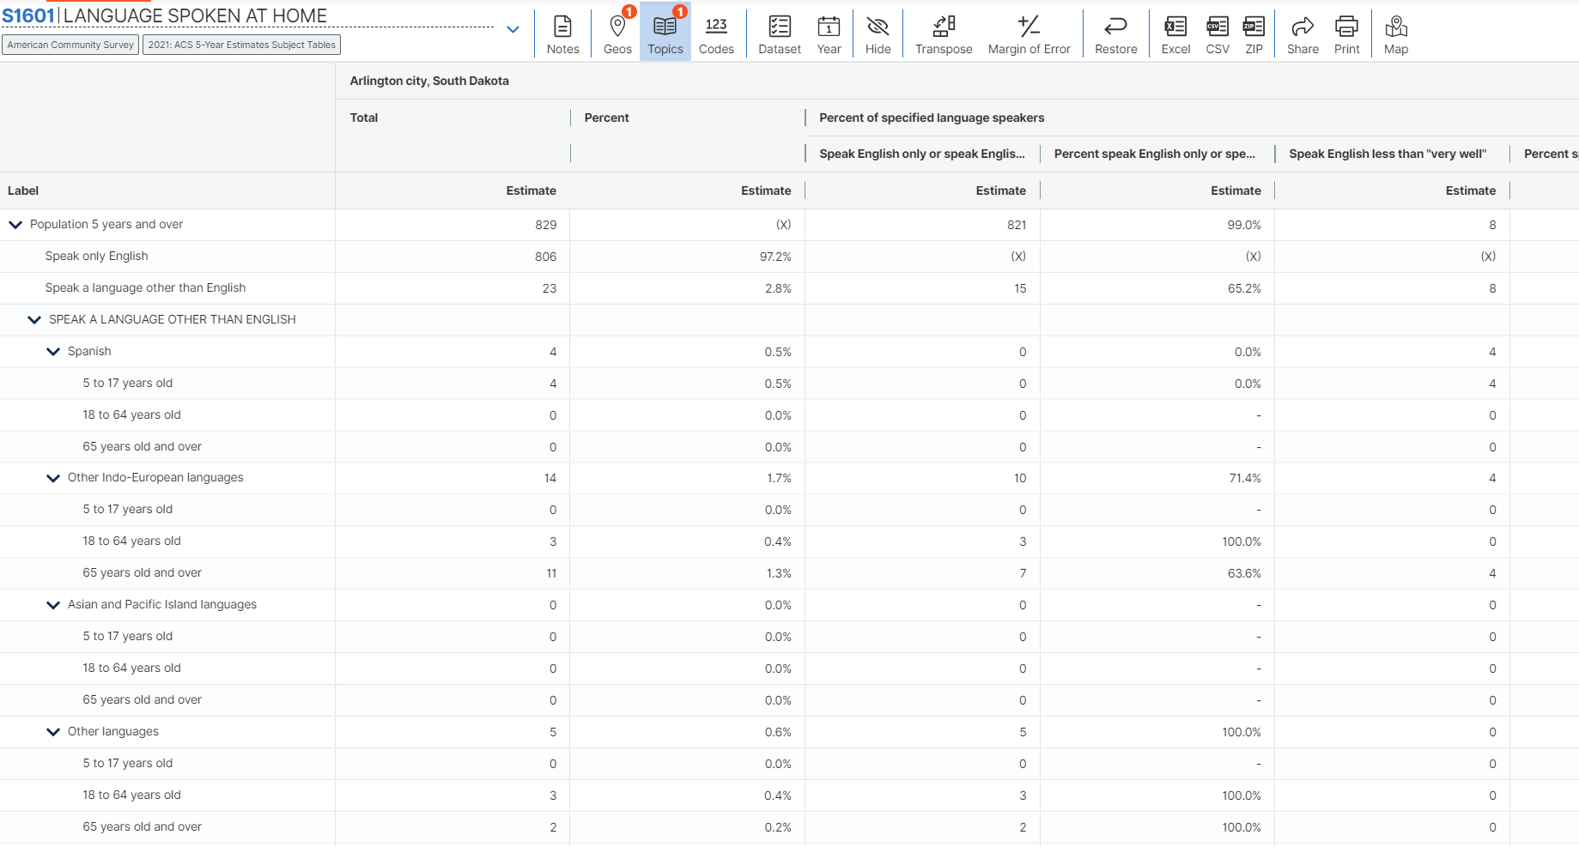

Note: The column titled “Percent speak English less than very well” is calculated as only a percentage of those who “do not speak English very well” in that specific language other than English; not the percentage within your community as a whole. For example, in the screenshot below of all “Spanish speaking” residents, 9% speak English less than very well. You must calculate the number of people who “Speak English less than very well” against your total population. See the examples below for Pierre, SD.

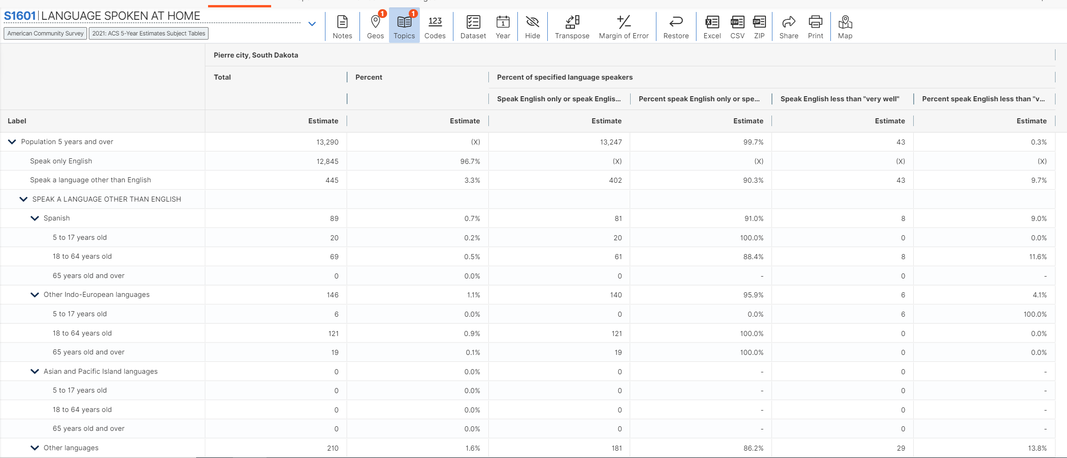
For Pierre, SD, the total population is estimated at 13,290 people with only 8 persons who speak Spanish and do not speak English very well, which equals 0.06 percent.

NOTE: An 'N' entry in the estimate and margin of error columns indicates that data for this geographic area cannot be displayed because the number of sample cases is too small. An '(X)' means that the estimate is not applicable or not available.

- If the grantee determines it does meet the threshold of the lesser of 1,000 people or 5% LEP persons of one or more languages, then the grantee will be required to complete an LAP. The Grantee will use Factors #2 through #4 to inform the elements of the LAP. If the Grantee determines that it does not meet the minimum threshold for any individual language they must proceed with Factors #2 through #4 to determine if an LAP will be required.

FACTOR #2
If the project offers direct assistance to beneficiaries related to housing and other services, the nature of the activity or service may be significant to the proposed project area residents. Additionally, all public participation activities must be open to the public. Grantees must assess the frequency of resident contact based on their chosen activities.
If the grantee determines that the program or activities provide direct assistance to residents who have LEP, then the residents are likely to have considerable direct contact, and the grantee will be required to complete an LAP. The Grantee will use Factors #2 through #4 to inform the elements of the LAP.

FACTOR #3
The more important the activity, or the greater the possible instances of contact with LEP persons, the more likely the need for language services. To determine the nature and importance of the programs, activities, or services provided to persons with LEP, the Grantee should consider the negative impacts on LEP persons who are not able to access these benefits. Determine whether the project will provide critical improvements such as a new community service center or public facility to serve low- and moderate-income people with a significant number of LEP persons or a primary focus on LEP persons. The benefits of such projects have an important impact on LEP residents. If the project is found to have such importance, the grantee will be required to complete an LAP. The Grantee will use Factors #3 and #4 to inform the elements of the LAP.

FACTOR #4
There are many resources available to grantees to assist LEP persons. Those resources include translation websites, translated documents available from HUD and DOL, and the eligible use of administrative funds from the CDBG program. Grantees should be able to provide language access at a reasonable cost. Grantees should not use cost reasons as the only factor to determine the need for language assistance.
If the grantee determines that none of the factors apply to it and its program, then it does not need to develop an LAP. Grantees should still make reasonable attempts to accommodate the language access needs of residents requesting oral translation during public participation and for other materials.
Grantees can also consider training staff and using HUD’s “I Speak” cards in their office for LEP persons who walk in. HUD’s “I Speak” cards and some translated materials are available at this website: https://www.hud.gov/program_offices/fair_housing_equal_opp/17lep

LANGUAGE ACCESS PLANS
If the grantee must prepare a Language Access Plan (LAP), use the Sample LAP provided in a separate attachment. Additionally, HUD has established certain “safe harbor” guidelines for written materials. That guidance is:
Size of Language Group | Recommended Provision of  Written Language Assistance
1,000 or more in the eligible population in the market area or among current beneficiaries | Translate vital documents.
More than 5% of the eligible population or beneficiaries and more than 50 in number | Translate vital documents.
More than 5% of the eligible population or beneficiaries and 50 or less in number | Translate written notice of right to receive free oral interpretation of documents.
5% or less of the eligible population or beneficiaries and less than 1,000 in number | No written translation is required.

