Once it is determined that a construction project is subject to federal labor standards provisions, the following steps must be taken to ensure compliance.
Step 1: Download Applicable Federal Wage Rate Decisions
The grantee should access the federal wage rate decisions through the Internet at https://sam.gov/content/wage-determinations.
When accessing a wage decision for the first time, Grantees should click the Public Building or Works box.
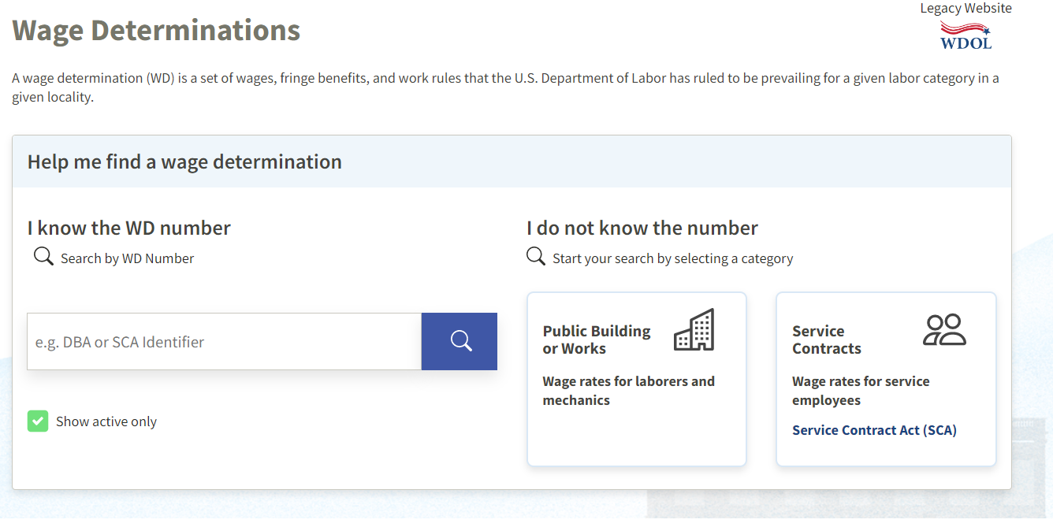

Note that federal wage determinations are issued for four categories: Building, Residential, Heavy, and Highway. Most CDBG construction projects will involve either Building or Heavy determinations. In determining which type of wage determination to request, it is important to understand the differences to avoid paying wages from an inappropriate determination.
Building construction generally includes construction of sheltered enclosures with walk-in access for housing persons, machinery, equipment or supplies. This includes all construction within and including the exterior walls, both above and below grade.
Residential projects involve the construction, alteration or repair of single-family houses or apartment buildings no more than four stories tall.
Highway projects include construction, alteration or repair of roads.
Heavy construction is generally considered for all construction not properly classified as Highway, Residential, or Building. Water and sewer line construction will typically be categorized as Heavy construction.
Next:
- Choose South Dakota from the dropdown box.
- Choose the county of the project from the dropdown box.
- Choose the construction type.
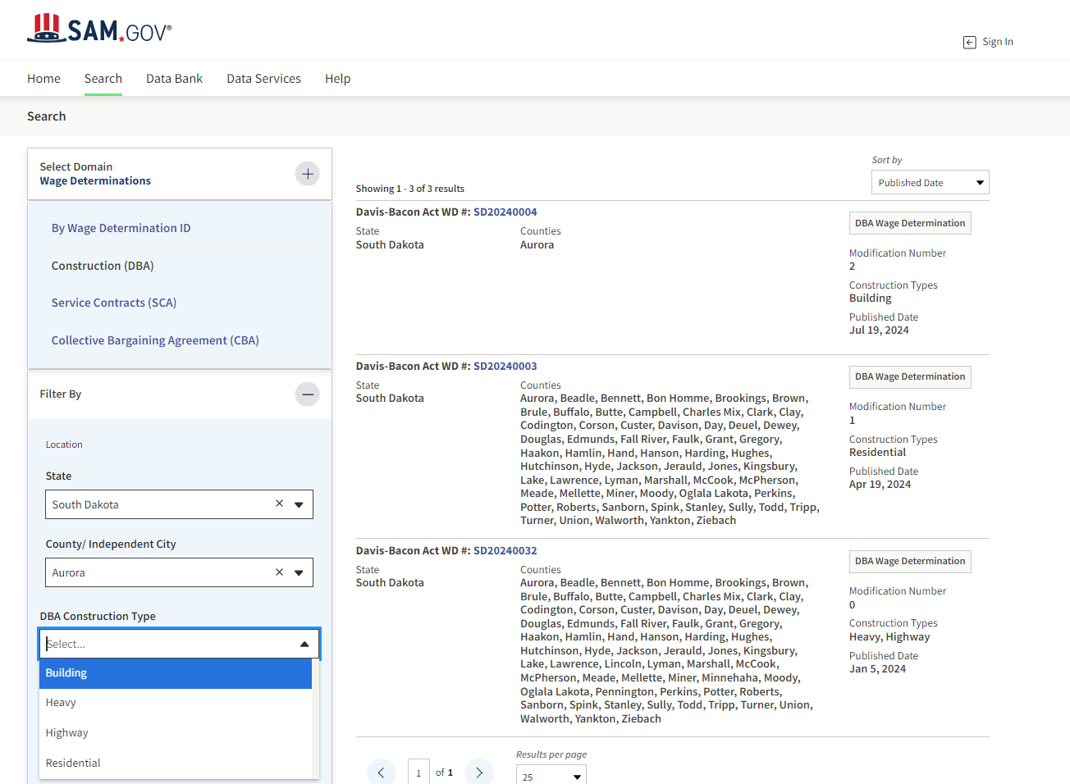
- Once you have selected the construction type the current applicable wage decision will appear. Click the Davis-Bacon Act WD # to download the wage decision.
1
3
2
4

The GOED Program Manager should be consulted if there are questions about properly identifying the type of construction on the project and the wage determination necessary, including those instances where the Grantee is required to request a wage determination from the Department of Labor.

